

School of Computing and Mathematics

PRCO303

Final Stage Computing Project

BSc (Hons) Software Engineering

Basura Ratnayake (10541973)

GRUHA PATHI – A New Frontier in Home Automation

2016/2017

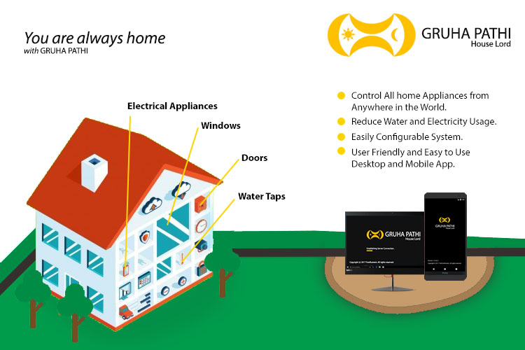

# Acknowledgement

The successful accomplishment of this undertaking could not have been possible without the contribution and assistance of so many of my good friends, elders, and lecturers whose names may not all be enumerated but their contributions are sincerely appreciated and I am forever grateful for them. I would like to express my deepest appreciation and indebtedness particularly

to the following:

My Family, friends who helped me in producing this work. I’m thankful for giving me strength, support in every angle and for their valuable time and contribution.

Mr. Udesh Amarasinghe my project supervisor for the great advice, new ideas, and the encouragement he provided throughout the project from the starting point to the ultimate result. I am grateful for his hard work and right guidance at each and every cornerstone of the project.

Mr. Pasan Eramusugoda my dear friend at my work place (Innodata Inc.) for his great contribution and support in helping me build, understand android programming and mobile related technologies.

Mr. Nalaka Fernando my superior and my dear friend at my work place for his great guidance, new concepts and understanding in granting me the freedom to continue my university work while working.

Mr. Amila Perera my dear friend at my work place for his great advice, new concepts, different way of thinking and the continuous guidance he provided.

They were the source of my inspiration that guided me to successfully accomplish this undertaking. Once again thank you all, without you this would never have been possible.

**Basura Ratnayake**

12th May, 2017

# Abstract

With the evolvement of advance technology, life is getting easier and comfortable in all aspects. Everyone wants an Automatic system over manual systems today, because automatic system made life smarter, and lives easy. Converting a manual home to a fully automated home automation system is very costly compared to building a new house with pre home automation technology integrated. The new trend of Internet is Internet of Things, but it is not a new concept because the IoT idea has been on the table for decades.

The concept behind IoT is connecting devices over internet and letting them talk to the user and each other to one days make them take decision for us. Smart Home Automation systems using IoT uses a computer or a mobile device to control home functions and monitor home status form any ware in the world. A goal of IoT and Home automation is to save electric power and human energy.

The Wireless home automation systems giver more advantages than wired home automation systems; such as, low installation cost, scalability and easy extension, integration of mobile devices. Wireless technology is suitable for already existing buildings and also for newly constructing buildings. (Vinay & Kusuma, 2015)

# Declaration

This is to certify that the work contained herein are the sole and original creations of **Ratnayake K Basura N B** and that no other external or referential creation/ source by a third-party, other than those cited, were taken-up/ included in the making of this Project. All ownership and copyright of this project resides with **Ratnayake K Basura N B** and all the copyrights of the libraries implemented in the project belong to their respective owners.

**Basura Ratnayake (10541973)**

Table of Contents

Acknowledgement 3

Abstract 4

Declaration 5

1 Introduction 8

2 Background, objectives & deliverables 9

2.1 Background 9

2.2 Objectives 9

2.3 Business Case 9

2.3.1 Business Needs 9

2.3.2 Business Objectives 9

2.4 Deliverables 10

3 Literature Review 10

3.1 Domain Research 10

3.1.1 Problem Identification 10

3.1.2 Extent in Determining the Scope 10

3.2 Technical Research 11

3.2.1 Sri Lanka Telecom 11

3.2.2 Dialog Axiata 11

3.2.3 HomeTEC Lanka Solutions 11

3.2.4 Innovative Smart Solutions 11

3.2.5 NOSTERS 12

3.3 Evaluating the Project Scope 12

4 Scope of the Project 13

4.1 Initial Scope 13

4.2 Updated Scope 13

5 Method of Approach 14

5.1 Development Method 14

5.1.1 Programming Paradigm 14

5.2 Software 14

5.2.1 Hardware Framework 14

5.2.2 Gruha Pathi API 14

5.2.3 Desktop Application 14

5.2.4 Mobile Application 14

5.3 Hardware 14

5.3.1 HUB Device 15

5.3.2 Smart Devices 15

6 System Requirements Specification (SRS) 15

6.1 Functional Requirements 15

6.2 Non-Functional Requirements 15

7 Components of the System 16

7.1 Software 16

7.1.1 Gruha Pathi API 16

7.1.2 Mobile Application 18

7.1.3 Desktop Application 20

7.2 Hardware 22

7.2.1 Smart Device Circuit 22

7.2.2 Smart Power Socket (SPS) 25

7.2.3 Smart Light (SL) 26

7.2.4 Smart Door (SD) 27

7.2.5 Smart Water Valve (SWV) 28

7.2.6 HUB 29

8 End-Project Report & The Post-Mortem 30

8.1 Lessons Learnt 30

Conclusions 31

References 32

Appendices I 35

User Manual of Gruha Pathi 35

Appendices II 44

Researched Products 44

HomeTEC Lanka Solutions 44

Innovative Smart Solutions 44

Sri Lanka Telecom 44

NOSTERS 44

Dialog Axiata 45

API Responses 45

Mobile Application 47

Desktop Application 49

Smart Devices 53

Project Initiation Document 55

Stage Plans 59

First Interim Report 60

Second Interim Report 64

Records of supervisory meetings 72

# 1 Introduction

The idea chosen for the was Home Automation, the project was named Gruha Pathi (GP) meaning House Lord. Gruha Pathi grants convenience, security and freedom for users to manage and organize their house and electrical/electronic appliances more efficiently.

All electrical equipment, water supply and house protection acts as a unified system that can automatically take decisions based on the information gathered from numerous sensors placed inside the house. Electricity consumption and total control over all the electrical appliance plugged into the system can be remotely controlled or let the system take decisions based on the information available.

Water flow management is one of the crucial factors that most systems fail to address in a house for the simple reason that Sri Lankans have plenty of water available in the country 24/7 but that doesn’t mean pure water is forever available in every part of the country. 80% of water is used in the kitchen and in cloth washing machines can be filtered and used in toilets with the help of Gruha Pathi.

*“Don’t let a single drop of rain water flow into the sea.”* – King Parakramabahu the Great.

Simply having a CCTV camera system never helps to protect a house from unwanted parties because after a crime has been committed there is very less reason with having only evidence but an automated system that can protect your house from unwanted parties is an ideal solution, with Gruha Pathi this is possible.

Time is a precious commodity that must not be wasted so instead of manually controlling appliances and knowing the usage it is better to be informed by an automatic system. The main key stakeholders of Gruha Pathi are the house owners. The main focus of Gruha Pathi was to provide total control of all house appliances to the user in an efficient and an easy to use manner.

The final smart devices and the applications were checked with several test cases and a test-driven development was effortlessly utilized throughout the entire development process. The testing revealed several glaring oversights in the design and helped refine the final implementation very much, especially in terms of potentially increasing efficiency.

# 2 Background, objectives & deliverables

## 2.1 Background

Home automation is the process of automating the manually controlled home appliance by controlling, monitoring and managing them through means of long range communication similar to the internet or any other communication medium.

## 2.2 Objectives

1. Build the system in a manner affordable to all types of premises.
2. Fully function smartphone application that can manipulate the system.
3. Complete standalone desktop application that can further enhance the manipulation of the system.
4. Fully functional hardware components that can work together or alone in a situation and are reliable.
5. To provide security and effective reliance of managing house tasks with ease.
6. Build a grand database of all survey information generated by individual systems to siphon information that can help develop the system further.

## 2.3 Business Case

### 2.3.1 Business Needs

Due to the present busy nature in Sri Lankan workforce, most of the household needs and maintenance are never done on time which paves the way tremendous expenses annually to only maintain and repair their houses and appliances. This scenario can be completely remedied through a unified home automation system that can easily help maintain and organize household needs.

Many seek automated solutions to accomplish daily tasks therefore; the present market for home automation in Sri Lanka is very competitive but most available products for home automation are separate components that acts individually rather than a complete unified system and a powerful local manufacture is almost non-existent therefore the market is right for the picking.

### 2.3.2 Business Objectives

* Establish an awareness of the advantages of Gruha Pathi to increase sales.
* Effectively maintain and observe the electrical and water consumption of a house.
* Implement an effective and efficient household protection system that can work as an artificial security officer.
* Build the home automation system at an affordable cost thus the sale of a system can increase the profit.
* The consumption reports generated by the individual systems (With the consent of the house owner) can be used as surveys for the improvement of the system.

## 2.4 Deliverables

1. Smart hub device to control the Smart devices based on inputs from the apps.
2. Smart devices to control doors, windows, lights, power sockets and water valves.
3. A desktop application (Desktop App) that can control appliances and view consumption details of appliances in a house.

# 3 Literature Review

## 3.1 Domain Research

### 3.1.1 Problem Identification

The basic idea of the initial project problem gets defined by evaluating its scope. In the present, the busy life style of an employed individual or a family doesn’t allow them the necessary time to take care of a house or an apartment. This in return results in,

* Electrical equipment not turned off while not using. For an example lights not turned off in the morning, Fans switched On when no one is around and etc.
* Water taps not properly closed.
* House doors and windows not properly closed at night.

When an equipment is not properly used it gets damaged and the same can be said about a house. When things are not properly taken care of, the house owners have to incur a tremendous amount of wealth every month to just to fix the broken things and pay the pay the bills on wastage. More importantly if a burglar happened to enter the premises at night through an improperly closed door or window not only the wealth is in danger but also the lives of the people living inside is also at jeopardy.

### 3.1.2 Extent in Determining the Scope

Time is a precious commodity that must not be wasted on tasks that can be automated therefore instead of manually manipulating appliances and determining the consumption of those appliance, it is better to be informed by an automatic system that can perform almost all of the tasks performed manually.

For this scenario, the targeted implementation should address to manage the resources and increase efficiency in a potential house by-

* Measuring the electrical and water consumption from each appliance and then calculate the total consumption in order to generate a near approximate payable amount at the end of the month.
* Ability to set a limit in electrical and water consumption.
* Ability to control the appliances remotely and let system turn off devices when no one is around.
* Ability to use alternate power systems for electricity appliances in case of a power failure.
* Automatic door and window locking at night and activate security to features to protect against threats.

## 3.2 Technical Research

There are many home automation systems in the world but focus of the research was directed at home automation systems currently available in Sri Lanka because the new system will be specifically implemented for Sri Lanka users. To aid in the construction of Gruha Pathi, the following systems have been researched in-depth.

### 3.2.1 Sri Lanka Telecom

Sri Lanka Telecom (SLT) became a corporation in 1991 with primary objective of providing telecommunication throughout Sri Lanka (Srilanka Telecom, 2017). SLT imports home automation devices from abroad and sell them in Sri Lanka. Most of SLT’s products are expensive for an average home owner.

SLT advertise a variety of products and the one focused on the research was the Wireless Removable Socket (Research Product 5) supports the new generation of ZigBee technology and the device monitor power consumption and send data to mobile terminals via wireless network (Srilanka Telecom, 2017). Smart Water Valve (Research Product 9) transmits consumption data to the SLT system.

### 3.2.2 Dialog Axiata

Dialog became a corporation in 1993 with the primary objective of enhancing the telecommunication sector. Similar to SLT, Dialog imports home automation components from Movinta (Dialog Axiata PLC, 2017). Smart Remote (Research Product 7) acts as a hub that can transmit data to other device such as Smart Plugs (Research Product 8) through a Wi-Fi connection,

### 3.2.3 HomeTEC Lanka Solutions

HomeTEC Lanka is a Home Automation Solution providers since 2008. HomeTEC uses Radio Frequency(RF) to send and receive signals (HomeTEC Lanka Solutions, 2017). According to (HomeTEC Lanka Solutions, 2017) their systems (Research Product 1 & 2) can be used to control any kind of electronic/electrical devices. The most sophisticated devices in HomeTEC Lanka Solutions is the Motion Sensor (Research Product 3), turns lights On or Off when someone moves in and automatically switches On when darkness falls.

HomeTec Lanka Solutions offer products for a fair price (HomeTEC Lanka Solutions, 2017) but the main disadvantage of the mentioned systems is that they require specialized training and knowledge to get configured and installed.

### 3.2.4 Innovative Smart Solutions

Innovative Smart Solution was incorporated in December 2012 with primary objective of manufacturing Narrowband PLC Modems and related products in Sri Lanka (Innovative Smart Solutions, 2017). Innovative Smart Solutions offer a variety of products ranging from modems to house hold plugs. Smart Plugs (Research Product 4) can be controlled using any Wi-Fi enabled device such as a smart device.

### 3.2.5 NOSTERS

NOSTERS provide customized solution to fit customer budget. NOSTERS basically provides four products types which are Building Management Systems, Network Solutions, HVAC Control Solutions and Lightning & Shades Control Systems (NOSTERS, 2017).

NOSTERS Lightning Automation (Research Product 6) system can control lighting from a master keypad or by a remote to easily change the visual environment and these systems are suitable for large environments.

## 3.3 Evaluating the Project Scope

Exploring different types of available home automation systems according to the problem parameters, it’s clear from already available research that only through combining multiple types of advantageous features of those system and inventing new features is the most optimal solution be implemented.

The following points are summarized as advantages from the above mentioned home automation systems and are chosen as the features to be implemented in the project.

* An array of devices has to be designed to manipulate the workings of the house allowing the system and the users to-
* Turn ON/OFF electrical appliance.
* Turn ON/OFF water supply.
* Activate/Deactivate house security features.
* LOCK/UNLOCK doors and windows.
* Provide consumption of appliance to the system every hour.
* A central hub has to designed to gather details and provide commands to each device according to commands updated in the central database.
* An API has to be developed to upload and download data from and to the central database.
* An android application and a desktop application has to be developed to let users interact with the main hub to give commands and get appliance consumption data.
* Reduce or fully eliminate the need to configure devices before being installed in a premise thus eliminating the need for special expertise to install smart devices.
* Reduce the unnecessary electricity and water wastage in a premise by automatically turn off devices that are not being used.
* Reduce internet usage of smart devices by introducing RF 433MHz frequency for communication between smart devices and hub therefore; only the hub needs to access the internet to obtain commands.

# 4 Scope of the Project

## 4.1 Initial Scope

1. User will be able to monitor
   1. Current power status of the home appliance.
   2. Check water level of the water tank
   3. Home temperature and humidity
2. User will be able to open house door/windows.
3. Home Security System (burglar Detection)
4. User will be able to do above mentioned things using android application or desktop application from anywhere in the world through the Internet.

## 4.2 Updated Scope

The initial scope had to change in order to properly implement a working prototype system. The scope changes and the reason for the changes are stated below:

* **Removed Features**

Due to the limitation of time the following features were removed from the system

* Burglar Detection System.
* Home Temperature & Humidity.
* Water Level of the Water Tank.
* **Changed Features**
* The ability to modify the system through the mobile application was removed, instead through mobile application the user can turn ON/OFF devices and get water and electricity consumption of devices.
* **Added Features**
  + Through the desktop application, the user can design a layout of their house floors and place devices at places they desire.
  + Security layer added to API to protect sensitive information of users and their appliances.
  + Mobile application grants access to the desktop application through QR based authentication.
  + Reduce internet usage of smart devices by introducing RF 433MHz frequency for communication between smart devices and hub therefore; only the hub needs to access the internet to obtain commands.
  + Automatically turn off devices that are not being used by taking five minutes as the margin for device inactivity.

# 5 Method of Approach

## 5.1 Development Method

Agile based component development was chosen for the project since Agile based development paves the path for prototyping (Agile Alliance, 2017) of components both hardware and software.

### 5.1.1 Programming Paradigm

Object Oriented Programming (OOP) paradigm was chosen as the coding style for software applications.

The system was developed to consists mainly of a software system and an array of hardware devices spread throughout a premise.

## 5.2 Software

### 5.2.1 Hardware Framework

#### 5.1.1.2 HUB Framework

The HUB framework communicates with the API through the internet and transmits the received commands to the smart devices and receives consumption data from smart devices and transmits to the API

#### 5.1.1.3 Smart Device Framework

The Smart Device framework controls the hardware components of the device and perform relevant actions based on the commands received from HUB and transmits consumption data to the HUB.

### 5.2.2 Gruha Pathi API

The API acts as the nervous system of the entire Gruha Pathi system therefore; directly communicates with both hardware and software to send and receive commands and data.

### 5.2.3 Desktop Application

The desktop application sends and receive data from and to the API based on interactions from a user.

### 5.2.4 Mobile Application

The desktop application sends and receive data from and to the API based on interactions from a user. The user can only turn ON/OFF devices and view device consumption data.

## 5.3 Hardware

Hardware framework was installed in all the smart devices and hubs to enable communication with each other and with the API.

### 5.3.1 HUB Device

The HUB Device use the installed framework to command the electronic components inside the HUB.

### 5.3.2 Smart Devices

There are four types of smart devices in the system and all of them share the same framework with minor alterations to perform their specific tasks. The commands received from the HUB are used to control the electronic components of the smart device.

# 6 System Requirements Specification (SRS)

## 6.1 Functional Requirements

The Needed Functionality of the Information System.

1. Android App for Mobile.
2. Windows App for Desktop.
3. Monitor Power Socket Electrical Consumption.
4. Switch ON/OFF Power Socket Remotely.
5. Monitor Light Electrical Consumption.
6. Switch ON/OFF Light Remotely.
7. LOCK/UNLOCK Door, Window and Gate Remotely.
8. Monitor Water Consumption Remotely.
9. Switch ON/OFF Water Supply.
10. Limit Water Usage.
11. Communication between electronic appliances are encrypted using ever changing primes.

## 6.2 Non-Functional Requirements

The Additional Functionality of the Information System.

1. User Friendly GUI (Graphical User Interface) for android and desktop applications.
2. High Speed Communication between appliances.
3. Powerful changing encryption (Keys change every 30 minutes) that uses RSA encryption.
4. Easy configurable system (Hardware and software).
5. Obtain Reports of House Status (Electricity, Water and Protection).
6. Voice activated commands and tasks.
7. Monitor Door, Window and Gate Status Remotely.
8. Encryption keys change every 30 minutes.

# 7 Components of the System

The system comprises of three main software and five main hardware components.

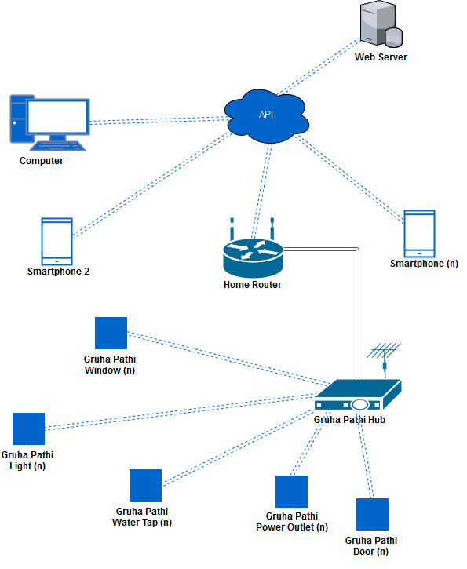

## 7.1 Software

### 7.1.1 Gruha Pathi API

The API acts as the nervous system of Gruha Pathi which handles data transmissions and database storage of devices and applications. The API was implemented using the server side language PHP and follows the REST architecture since the API acts as the nervous system an extra layer of Token based security was added to the system. In other words, every action requires an authentication token to receive and transfer data from and to the system and vice-versa. Full list of the API operations (API Response All) are stored in the JSON format using Postman.

#### 7.1.1.1 Operations Performed

**User Authentication and Registration**

When a user registers with Gruha Pathi, login credentials are issued to the user in order for them to gain access to the system and a user account can have multiple descendent users that are capable of accessing the system.

**User Login: Using Username and Password**

When a user login into the system with the company issued login credentials and a authentication token (API Response 1) is generated and sent in the JSON format to the application to enable continuous communication between the API and the application. An authentication token expires every hour and a refresh token is passed to refresh the authentication.

**User Login: Using Mobile QR Code Scan**

A user can login into the system by scanning a random generated QR code (API Response 2) in the Desktop application using the Mobile Application and a JSON response (API Response 3) is returned to the desktop application with the authentication token (API Response 4).

**Smart Devices CRUD Operations**

Desktop and mobile applications can get the devices assigned to their user accounts using the authentication token and the JSON response (API Response 5) can be filtered by ‘Assigned Devices’ and ‘Device Id’ parameters. The system output a JSON response (API Response 7) based on the parameters ‘Device Location’, ‘Device Power State’ and ‘Device Id’.

Desktop application can modify the device parameter ‘Assigned’ in the system using the authentication token and the changed device state is returned as a JSON response (API Response 6). The desktop and mobile application can modify the device parameters ‘Device Name’, ‘Power State’, ‘Device Location’, and ‘Rotate State’ and the changed device state is returned as a JSON response (API Response 8). Smart device has a virtual resemblance in the system therefore a user can remove a virtual device from the system but not the details of the actual device, in other words when a user removes a device the virtual instance is removed and the device assigned state is changed into ‘No’.

Smart devices transmit water or electricity consumption data (API Response 10) to the API every hour using the HUB. Desktop and mobile applications can view consumption data (API Response 9) and filter them using a date range and a power medium (Electricity or Water).

#### 7.1.1.2 Used Technologies

**PHP**

PHP (Hypertext Pre-processor) is an open source server side scripting language that handles requests from clients and responses from servers (PHP Group, 2017). PHP systems are usually hosted on Apache servers, which is another open source software. PHP works well when working hand in hand with MySQL.

**MySQL**

MySQL (Structured Query Language) is an open source Database Management System (DBMS) that can be hosted on a server or a local machine (MySQL, 2017) and works well with almost all server side and desktop programming languages.

**MVC**

MVC (Model View Controller) is a software architecture that greatly helps in code reusability (MVC ASP.Net, 2017) and separates data from view and views from controllers for ease of programming.

**REST**

REST (Representational State Transfer) is a software architecture that communicates in a stateless manner which helps APIs to communicate with all software systems without restrictions (REST API Tutorial, 2017) and the main advantage of RESTful services is that they are simple and portable when needed to relocate code.

**JSON**

JSON (JavaScript Object Notation) is a lightweight data exchange format (JSON, 2017) that is easy to use and manipulate with almost every programming language.

**JWT**

JWT (JSON Web Token) is an open standard for creating JSON based authentication tokens (JWT, 2017). Web Tokens work well with both desktop and server side applications.

### 7.1.2 Mobile Application

Mobile application is used to turn On or Off smart devices connected to the system and to view electricity and water consumption of all smart devices. Mobile application was designed as a device that can grants access to the desktop application using QR code based authentication.

#### 7.1.2.1 Operations Performed

**Application Loading**

When the mobile application is executed the splash screen (Mobile App: Splash Screen) loads, this screen checks for the availability of an internet connection and the availability of the Gruha Pathi API. If no internet connection or API availability is detected, then an error message is displayed to the user asking the user to connect to the internet.

**Login: Using Username and Password**

User can login (Mobile App: Login Screen 1) into the system by entering the company provided login credentials into the mobile application and validating the login credentials with the API (API Response 1). A JSON based response is returned to the mobile application confirming the user credentials and if incorrect login credentials are provided relevant error messages are displayed to the user.

**Login: Using Mobile QR Code Scan**

User can login (Mobile App: Login Screen 2) into the system by scanning the QR code generated by the desktop application using the Mobile Application (API Response 2).A JSON based response is returned to the API confirming the QR Code and then the desktop application receives that authentication token and grants access to the desktop application.

**Summary of Gruha Pathi System**

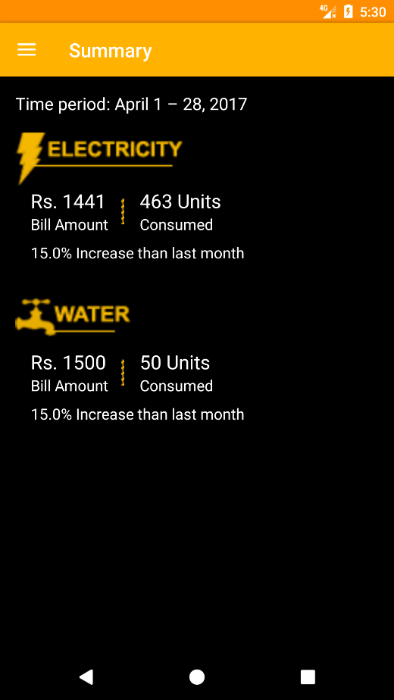User can view the electricity and water consumption from the starting of the month to the current date with the Summary Screen (Mobile App: Summary Screen). The consumption details are passed to the mobile application using the API (API Response 9).

The screen displays he amount payable, units consumed and the amount of units reduced by using the Gruha Pathi system.

**Device Selection**

User can search for devices (Mobile App: Device Screen) in floors or rooms or based on device types then the user can power On or Off the devices connected to the system (API Response 7) the process directly connects to the API to relay the information.

**Consumption Details**

Users can view the consumption details (Mobile App: Usage Screen) of all or a specific device by contacting the API (API Response 9) to receive the details of the devices and then the JSON data is processed through the mobile application to output to a user understandable format.

#### 7.1.2.2 Used Technologies

**JAVA**

Java is an open source programming language that can run on any operating system (Java, 2017).

**Android**

Android is a smartphone application development framework which was written by Google (Google, 2017). Android utilizes Java as the base for programming native android applications. Android is most widely used smart phone application development framework. Android app are developed as separate components(Activities) that can be invoked by the user individually. An activity is a single screen which has user interfaces. An activity can invoke another activity using an Intent.

The interface in Android applications are usually written as a xml file. Developers can also generate GUI components(Views) from java codes (Google, 2017).

**Espresso**

Espresso is a testing framework for testing android user interfaces to ensure that users never have to encounter unexpected results while running the application (Android Testing, 2017).

**Crashlytics**

Crashlytics is a real time error reporting service developed by Fabric that helps developers to track errors while the users are using the application (Fabric, 2017).

**Mobile Vision**

Mobile Vision is developed by Google Play Services allow latest android libraries to be automatically installed into the application (Google Developer, 2017).

**GSON**

GSON is an open source JSON handling library written in Java by Google (GSON, 2017) to work in android based systems.

**Retrofit**

Retrofit is library written in java to handle API requests and transform them into Java Interfaces (Retrofit, 2017).

**Butter Knife**

Butter Knife was used to automatically cast layout items into views in the layout (Jake Harton, 2017).

**Retro Lambda**

Retro Lambda allows Java lambda expressions, method references and try-with-resources to work in android applications (orfjackal, 2017).

### 7.1.3 Desktop Application

Desktop application acts as the command centre of a Gruha Pathi system. All layout designing, data transmission handling is controlled by using the desktop application. Unlike the mobile application through the desktop application all aspects of the system can be configured and arranged to the likeness of the user.

#### 7.1.3.1 Operations Performed

**Application Loading**

Check for an internet connection and the availability (Desktop App: Splash Screen) of the Gruha Pathi API. If no internet connection or API availability is detected, then an error message is displayed to the user asking the user to connect to the internet.

**Login: Using Username and Password**

User can login (Desktop App: Splash Screen) into the system by entering the company provided login credentials into the mobile application and validating the login credentials with the API (API Response 1). A JSON based response is returned to the mobile application confirming the user credentials and if incorrect login credentials are provided relevant error messages are displayed to the user.

**Login: Using Mobile QR Code Scan**

User can login (Desktop App: QR Code) into the system by scanning the QR code generated by the desktop application using the Mobile Application (API Response 2). A JSON based response is returned to the API confirming the QR Code and then the desktop application receives that authentication token and grants access to the desktop application.

**Build Floor Layouts**

User can create the floors layouts (Desktop App: Floor Screen) of a premise using the desktop application by placing rooms, doors, windows, light, power sockets and water valves that resemble smart devices.

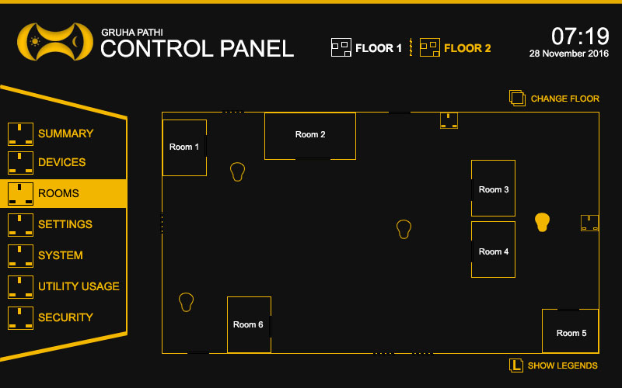

The added devices or rooms are then send to the API for storage. This is one of the most advanced features of Gruha Pathi.

**Change User Settings**

User has the freedom to change the password, email, and other user related details (Desktop App: Settings Screen) without affecting the functionality of the system. The request is sent by the desktop application to the API directly.

**Retrieve Installed Device Details**

The signal strength of the hub is transmitted to the desktop application through the API and all data related to the hardware and software details are retrieved from the API.

**Retrieve Consumption Data**

Users can view the consumption details (Desktop App: Usage Screen) of all or a specific device by contacting the API (API Response 9) to receive the details of the devices and then the JSON data is processed through the mobile application to output to a user understandable format.

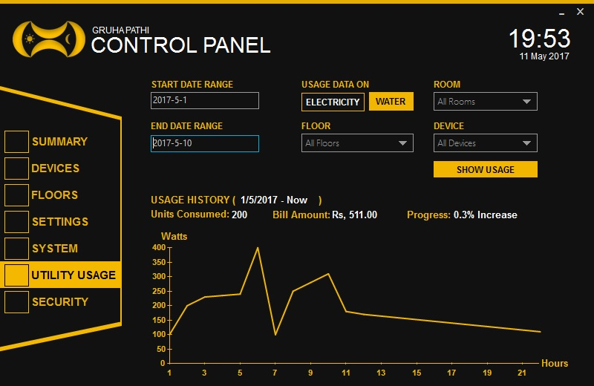

#### 7.1.3.1 Used Technologies

**C#**

C# was development Microsoft and included in all version of MS Visual Studio (Microsoft Docs, 2017). C# is one of comfortable to use Object Oriented Programming Language (OOP) with a great front for creating magnificent user interfaces and data structures.

**RestSharp**

RestSharp is a library designed for .NET applications to handles the communication between the API and the desktop application (RestSharp, 2017).

**Metro Modern UI**

Metro Modern UI is used to enhance the graphical user interfaces (GUI) of the desktop application (MetroFramework, 2017).

**Json.NET**

Newtonsoft: Json.NET is used to serialize and desterilize JSON data in .NET based applications (NewtonSoft, 2017).

**QRCoder**

QRCoder is used to generate a QR Code (CodeBude, 2017) for the mobile application to scan and grant access to the desktop application.

## 7.2 Hardware

### 7.2.1 Smart Device Circuit

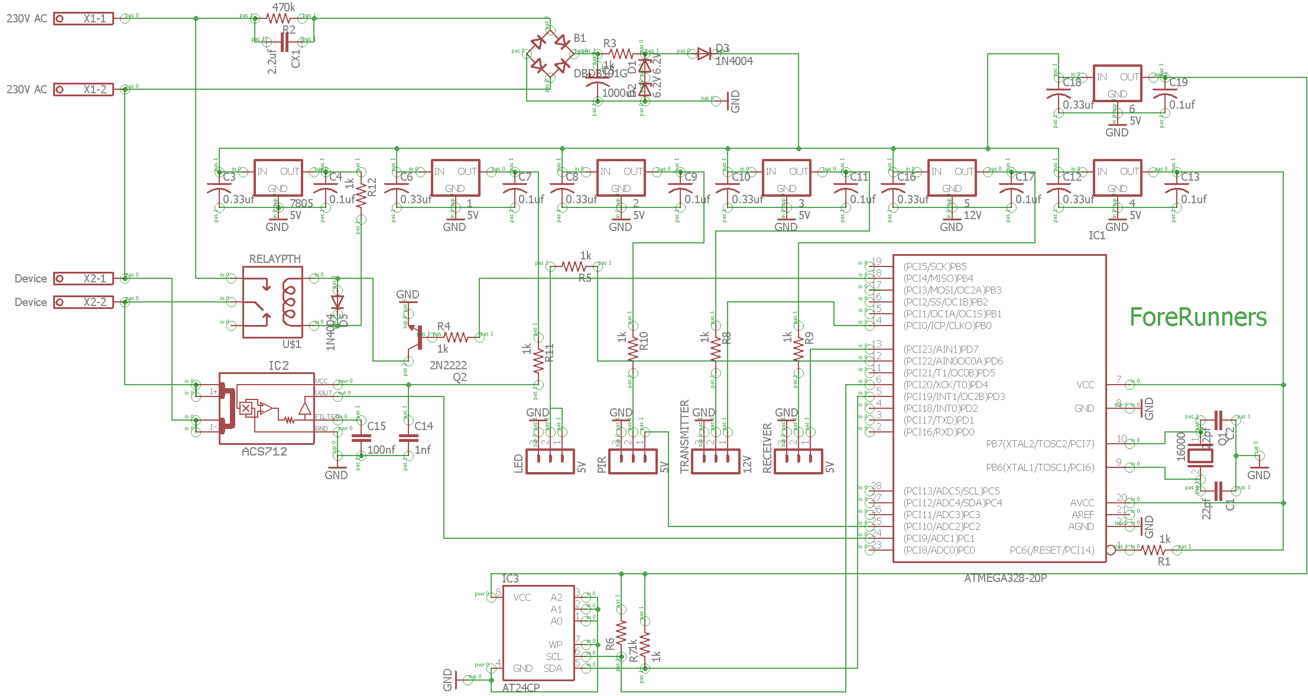

**Electronic Components of the Circuit**

* Electrolytic Capacitors (0.33μf, 0.1μ, 1000μf, 1nf, 100nf)
* Ceramic Capacitors (22pf)
* Resistors (100Ω, 1kΩ)
* Bridge (2A AC-DC)
* Transistors (PN2222A)
* Integrated Circuits (ATMEGA328-PU, 24C64, ACS712)
* Zener Diode (6.2V)
* Diode (1N4007, LED)
* Relay (230VAC 5VDC)
* Crystals (16k)
* 433MHz transmitter and receiver

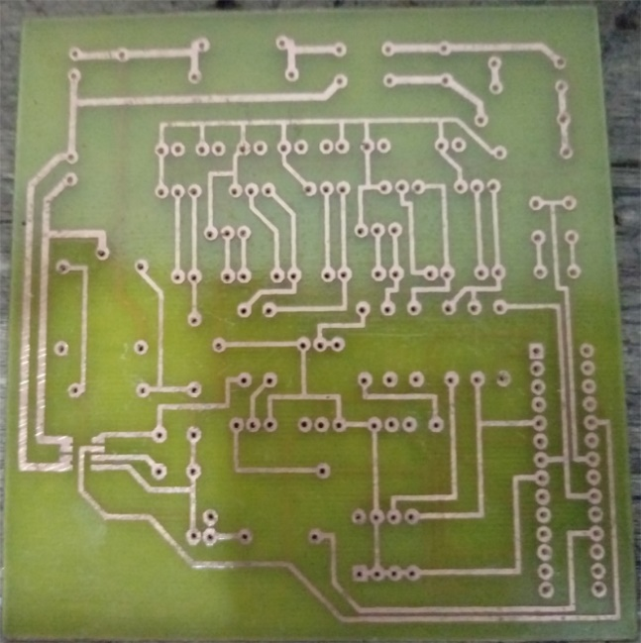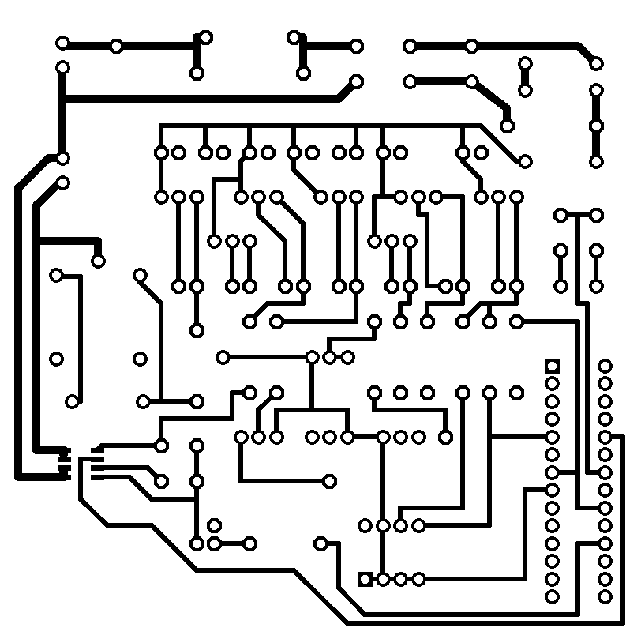 **PCB Design of the Circuit (Paper) Printed PCB (Copper Board)**

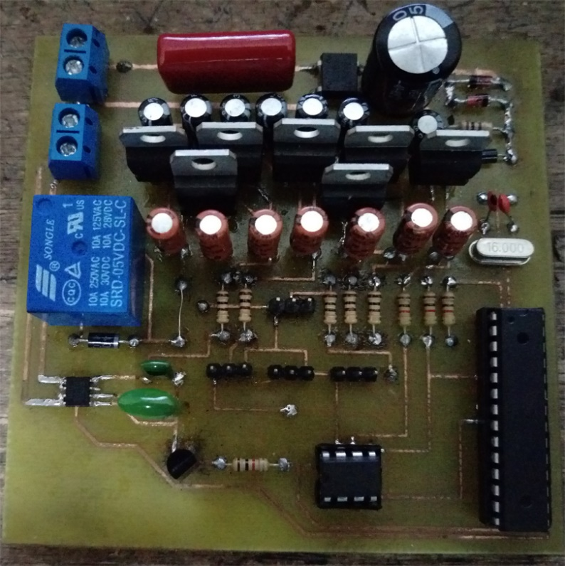**Soldered PCB**

The PCB (Printed Circuit Board) was completely homemade using the Toner Transfer Method (Elliot Williams, 2017). The **uniqueness of the Smart device** **circuit** is that it can be used to manipulate almost any device with only a few alterations to the Smart Device Framework installed on the IC (ATMEGA328-PU).

**Workings of the Smart Device Circuit**

* **Voltage Transformation**

Transforming 230V AC (Mains) to 5V and 12V DC (Variable Outputs) with 1 amp posed a great challenge. To transform Mains to Variable output required an electrical transformer which was large in size, I fixed this issue by using capacitor based transformation and use voltage regulator ICs to obtain 12V, 5V DC respectively.

* **Wireless** **Communication**

RF 433MHZ wireless communication (RF Modules) is used to receive and transmit data and commands to and from devices. The issue faced here was the initial range of RF module transmission distance which was 12cm, after much research managed to solve it by using a signal booster and a 17cm long antenna.

* **Size of Components**

With the circuit prototype testing it became evident that size of the devices has increased by 20% in comparison to the initial planned component size. The solution for this issue would be to use SME (Surface Mounted Electronic) but I have no experience with them as of now, I plan to gain knowledge on the subject.

* **Size of Memory**

The storage capacity of ATMEGA328-PU is 32KB which is not enough to store all the planned functionality of the device therefore in order to solve the issue I used ROM IC 24c64 which contains a capacity of 32 KB the resulting storage capacity is 64KB (ATMEGA328-PU + 24c64).

**Unique Features of the Smart Device**

* **No Power Adapter Required**

No power adapter is required to convert AC to DC. The device can be connected to any power outlet and the circuit transform 230V AC to DC.

* **Configuration Less**

No device configuration is required. A user can purchase a device and plug it into the house power line and the system automatically configures and installs it into the system.

* **Encrypted Communication**

Every device is hard corded with a unique serial number and the HUB serial to which the device belong is hard corded into the device when a user purchases the device. All communication between the HUB and devices are encrypted using a Caesars Cipher (Learn Cryptography, 2017). All communications between the API and HUB are dealt with POST request, the post protected way of sending data over HTTP.

* **Scalability**

It is really convenient to add new devices into the system and to install upgrades. A user can purchase as many devices as a user desires and simply plug the devices into the house power lines, the system will automatically detect new devices and install them into the system device list.

* **Multi-Purpose Circuit**

The circuit developed for the system can be used to manipulate almost any device with the only a few alterations to the Smart Device framework installed on the IC.

**Types of Smart Devices**

Four main smart devices were developed to provide a variety of service to a user with the Gruha Pathi system.

* **Smart Power Socket**

Smart Power Socket can turn your old power socket into a Smart Power Socket. Once you plugged a device into the Smart Power Socket you can control the electric device which connected to it from anywhere in the world.

* **Smart Light**

Smart Light can turn your old light bulb into a Smart Light, once a user installed the Smart Light users would be able to control lights from anywhere in the world.

* **Smart Water Valve**

Smart Water Valve turns your old water valve into a Smart Valve that can be controlled from anywhere in the world.

* **Smart Door**

Smart Door is installed on top of the old lock thus turning it into a Smart Door that can controlled from anywhere in the world.

### 7.2.2 Smart Power Socket (SPS)

The smart power socket (Smart Device: Socket – Front) has the ability to transform a traditional power socket into a smart power socket and it has an inbuilt transmitter and a receiver to establish communication with the HUB.

#### 7.2.2.1 Workings of the SPS

* Calculate the electricity consumption of the appliance connected to the smart plug and transmits the electricity consumption every hour to the HUB.
* Activates and deactivates the power to the appliance using the relay installed in the SPS based on inputs from the HUB.
* PIR sensor installed in the SPS can activate and deactivate the relay based on motion.
* Deactivates the device automatically if not used for five minutes.

#### 7.2.2.2 Components Inside SPS

* All Components of the Smart Circuit
* PIR Sensor

#### 7.2.2.3 Prototype SPS

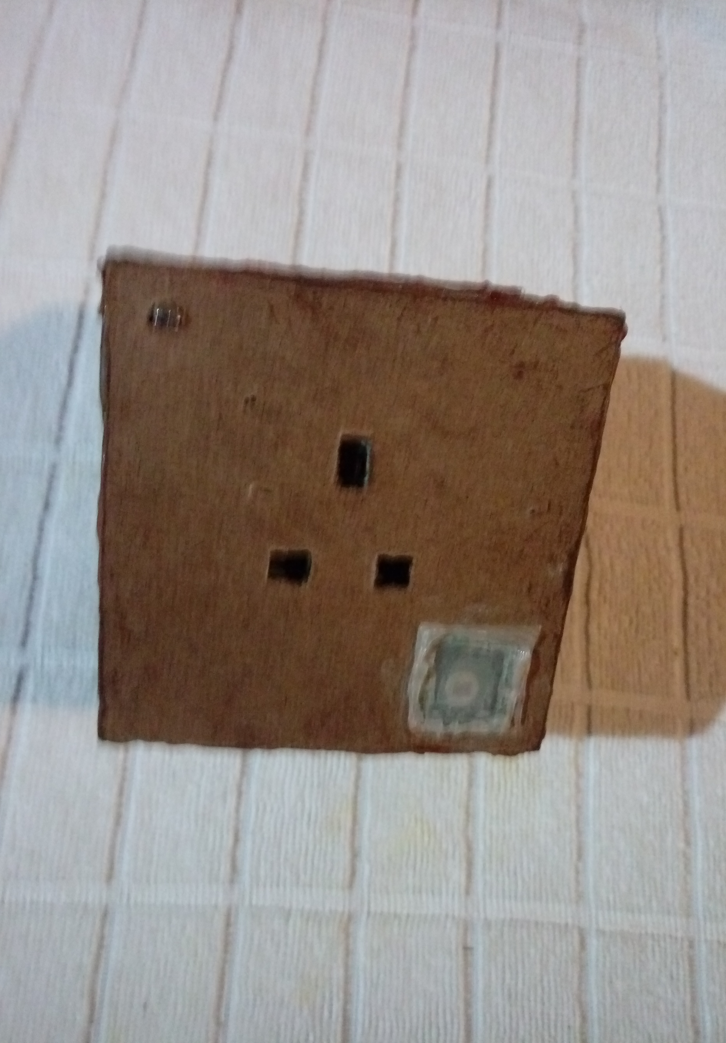

### 7.2.3 Smart Light (SL)

The smart light (Smart Device: Light - Front) has the ability to transform a tradition light into a smart light and share the common functionality of Smart Device Circuit.

#### 7.2.3.1 Workings of the SL

* Calculate the electricity consumption of the smart light and transmits the electricity consumption every hour to the HUB.
* Activates and deactivates the power to the light using the relay installed in the SL based on inputs from the HUB.
* PIR sensor installed in the SL can activate and deactivate the relay based on motion.

#### 7.2.3.2 Components Inside SL

* All Components of the Smart Circuit
* PIR Sensor

#### 7.2.3.3 Prototype SL

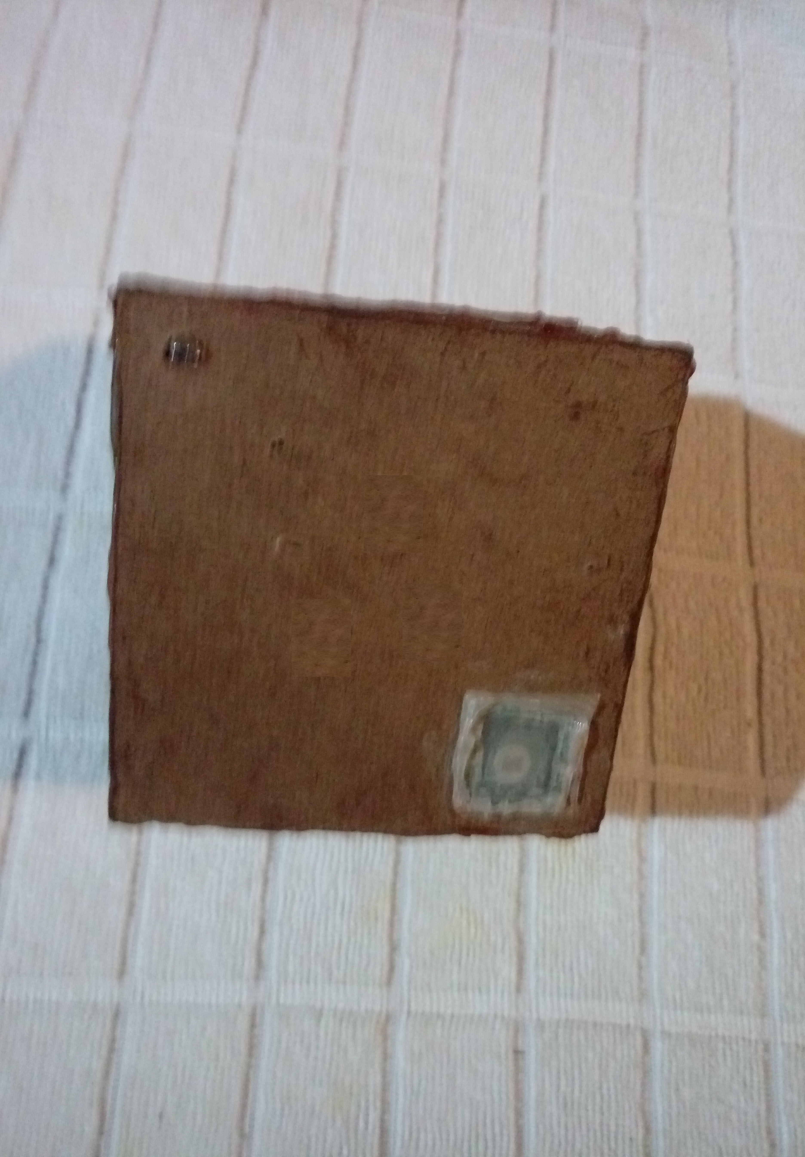

### 7.2.4 Smart Door (SD)

The smart door (Smart Device: Door) has the ability to lock and unlock a door or a window the smart door is installed on and share the common functionality of Smart Device Circuit.

#### 7.2.4.1 Workings of the SD

* Activates and deactivates the power to the lock using the relay installed in the SD based on inputs from the HUB.

#### 7.2.4.2 Components Inside SD

* All Components of the Smart Circuit
* 5V Servo

#### 7.2.4.3 Prototype SD

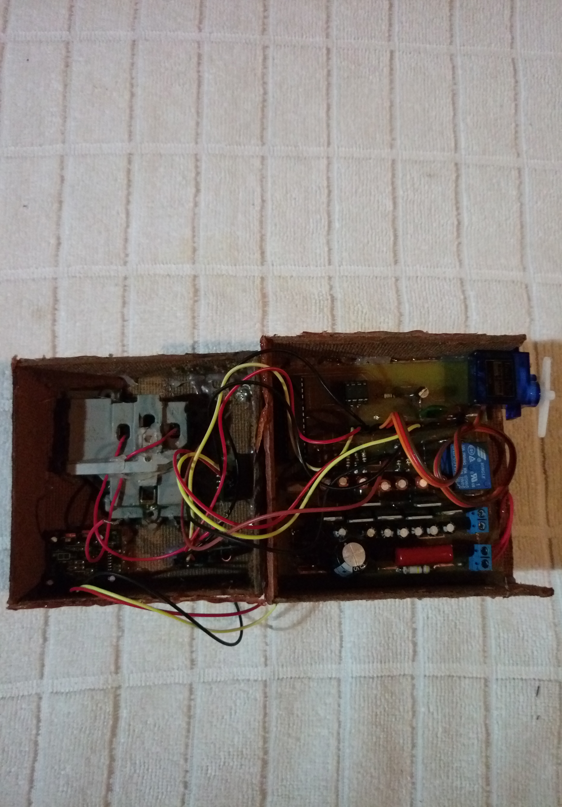

### 7.2.5 Smart Water Valve (SWV)

The smart water valve (Smart Device: Water Valve) has the ability to close and open a the smart water valve and share the common functionality of Smart Device Circuit.

#### 7.2.5.1 Workings of the SWV

* Activates and deactivates the power to the water valve using the relay installed in the SWV based on inputs from the HUB.
* Calculate the water consumption of the smart water valve and transmits the water consumption every hour to the HUB.

#### 7.2.5.2 Components Inside SWV

* All Components of the Smart Circuit
* 12V Solenoid Water Valve
* 5V Water Flow Sensor

#### 7.2.5.3 Prototype SWV

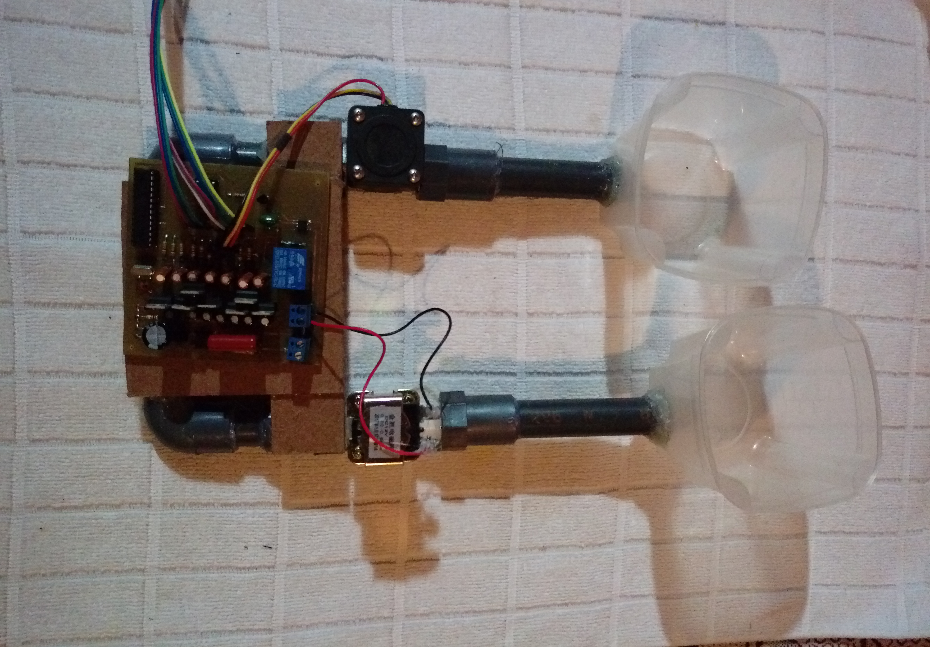

### 7.2.6 HUB

The smart water valve (Smart Device: HUB) has the ability communicate with API to send and receive commands. Share the common functionality of Smart Device Circuit but the HUB framework was installed on the IC.

#### 7.2.6.1 Workings of the HUB

* Transfer Commands to the Smart Devices.
* Receive Consumption data from Smart Devices and Send to the API.
* Communicate with API through the internet.

#### 7.2.6.2 Components Inside HUB

* All Components of the Smart Circuit
* HC-12 433MHz
* Ethernet Shield
* 433MHz Antenna

#### 7.2.6.3 Prototype HUB

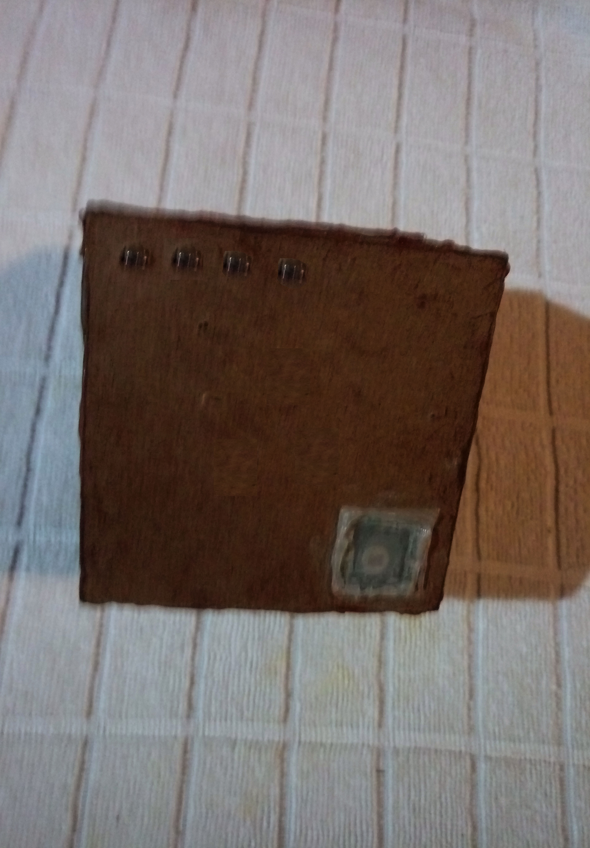

# 8 End-Project Report & The Post-Mortem

The initial scope of the project was changed due to time restrictions therefore some aspects were removed and new aspects were introduced to the scope. I can ensure with full confidence that all the aspects of the updated project scope were implemented and fully functional within the system.

The physical containers for the smart devices were intended to be constructed using plastic but due to the hardship of manipulating plastic into shape, the plan had to be changed to employ light weight wood for the construction of the devices. The use of light wood made the physical appearance of the smart devices a bit unappealing and somewhat different from the initial planned design.

The homemade PCB printing of the smart devices proved to be much effective and productive when building the smart devices and installing the hardware framework. However, the size of the smart devices could have been reduced significantly if SMEs (Surface Mounted Electronics) were to be used instead of traditional electronic components.

The agile development and the OOP paradigm were excellent selections in implementing a system such as Gruha Pathi.

The current mobile application can only run on android platforms therefore users with IOS and windows phones cannot use the mobile application. If hybrid mobile application development was used it would have paved the way for the user of all smartphone platforms to use the mobile application. Similarly, the desktop can only run on windows platforms therefore it would have been more accessible if written in QT C++.

The testing of the smart devices proved to be more successful than first anticipated. Confirming the efficiency and the effectiveness of the smart devices.

## 8.1 Lessons Learnt

* Gained sufficient knowledge to construct PCB designs from scratch and to print them on copper clad boards using the Toner Transfer Method (Elliot Williams, 2017).
* Gained knowledge and experience to build and handle electronic components and sensors.
* Construction of complete and efficient APIs to function as bridge for data transmissions.
* Implement cross-platform desktop applications to ensure that the application run on any PC platform (Windows, Unix, Mac) using QT C++ or similar.
* Implement hybrid mobile applications to ensure that the mobile application run on mobile platform and also can be utilized as a website since its most web based.
* Use SME components in circuit construction to reduce the size of the circuits.

# Conclusions

All stated functionality of the system was implemented and fully functional therefore the project can be concluded as a successful accomplishment.

It is evident from the project Gruha Pathi that an individual unified home automation system can be fully implemented that can cover all areas of a premise that needs to be automatically controlled or using the least amount of user interactions to accomplish a task in a premise. Since Gruha Pathi was designed to be flexible for scalability and configuration less installation it is the ideal solution suitable for all types of houses.

According to the realized facts of home automation systems in currently in Sri Lanka Gruha Pathi can be developed to a stage that will pave the path for a local business in Sri Lanka.

# References

1. Agile Alliance, 2017. *Agile Alliance.* [Online]   
   Available at: https://www.agilealliance.org/agile101/  
   [Accessed 05 08 2017].
2. Android Testing, 2017. *Testing Support Library.* [Online]   
   Available at: https://developer.android.com/tools/testing-support-library/index.html  
   [Accessed 08 05 2017].
3. Android.com, 2017. *Introduction to Android.* [Online]   
   Available at: https://developer.android.com/guide/index.html  
   [Accessed 10 05 2017].
4. CodeBude, 2017. *QR Coder.* [Online]   
   Available at: https://github.com/codebude/QRCoder  
   [Accessed 08 05 2017].
5. Dialog Axiata PLC, 2017. *Dialog and Movinta Pioneer Smart Home Technology.* [Online]   
   Available at: https://www.dialog.lk/smarthome  
   [Accessed 08 05 2017].
6. Elliot Williams, 2017. *Take Your PCBs from Good to Great: Toner Transfer.* [Online]   
   Available at: http://hackaday.com/2016/09/12/take-your-pcbs-from-good-to-great-toner-transfer/  
   [Accessed 08 05 2017].
7. Fabric, 2017. *Crashlytics for Android.* [Online]   
   Available at: https://fabric.io/kits/android/crashlytics/features  
   [Accessed 08 05 2017].
8. Google Developer, 2017. *Get Started with the Mobile Vision API.* [Online]   
   Available at: https://developers.google.com/vision/android/getting-started  
   [Accessed 08 05 2017].
9. Google, 2017. *Android Developers.* [Online]   
   Available at: https://developer.android.com/index.html  
   [Accessed 08 05 2017].
10. GSON, 2017. *Android JSON Parsing with Gson Tutorial.* [Online]   
    Available at: https://www.javacodegeeks.com/2011/01/android-json-parsing-gson-tutorial.html  
    [Accessed 08 05 2017].
11. HomeTEC Lanka Solutions, 2017. *Gadget Store.* [Online]   
    Available at: http://www.hometeclanka.com/gadget-store.html#OMS  
    [Accessed 08 05 2017].
12. HomeTEC Lanka Solutions, 2017. *HomeTEC Lanka Solutions.* [Online]   
    Available at: http://www.hometeclanka.com/about--contact-us.html  
    [Accessed 08 05 2017].
13. Innovative Smart Solutions, 2017. *Innovative Smart Solutions.* [Online]   
    Available at: http://smarthome.lk/  
    [Accessed 08 05 2017].
14. Jake Harton, 2017. *Butter Knife.* [Online]   
    Available at: http://jakewharton.github.io/butterknife/  
    [Accessed 08 05 2017].
15. Java, 2017. *Java Documentation.* [Online]   
    Available at: https://go.java/student-resources/index.html  
    [Accessed 08 05 2017].
16. JSON, 2017. *Introducing JSON.* [Online]   
    Available at: http://www.json.org/  
    [Accessed 08 05 2017].
17. JWT, 2017. *ntroduction to JSON Web Tokens.* [Online]   
    Available at: https://jwt.io/  
    [Accessed 08 05 2017].
18. Learn Cryptography, 2017. *Learn Cryptography - Caesar Cipher.* [Online]   
    Available at: https://learncryptography.com/classical-encryption/caesar-cipher  
    [Accessed 08 05 2017].
19. MetroFramework, 2017. *MetroFramework.* [Online]   
    Available at: https://thielj.github.io/MetroFramework/  
    [Accessed 08 05 2017].
20. Microsoft Docs, 2017. *C# Programming Guide | Microsoft Docs.* [Online]   
    Available at: https://docs.microsoft.com/en-us/dotnet/articles/csharp/programming-guide/  
    [Accessed 08 05 2017].
21. MVC ASP.Net, 2017. *MVC Framework - Introduction.* [Online]   
    Available at: https://www.tutorialspoint.com/mvc_framework/mvc_framework_introduction.htm  
    [Accessed 08 05 2017].
22. MySQL, 2017. *MySQL Documentation.* [Online]   
    Available at: https://dev.mysql.com/doc/  
    [Accessed 08 05 2017].
23. NewtonSoft, 2017. *NewtonSoft JSON.* [Online]   
    Available at: http://www.newtonsoft.com/json  
    [Accessed 08 05 2017].
24. NOSTERS, 2017. *NOSTERS.* [Online]   
    Available at: http://www.nostersworld.com/solutions.php  
    [Accessed 08 05 2017].
25. orfjackal, 2017. *Retrolambda: Use Lambdas on Java 7.* [Online]   
    Available at: https://github.com/orfjackal/retrolambda  
    [Accessed 08 05 2017].
26. PHP Group, 2017. *PHP: What is PHP? - Manual.* [Online]   
    Available at: php.net/manual/en/intro-whatis.php  
    [Accessed 08 05 2017].
27. REST API Tutorial, 2017. *What is REST? - REST API Tutorial.* [Online]   
    Available at: www.restapitutorial.com/lessons/whatisrest.html  
    [Accessed 08 05 2017].
28. RestSharp, 2017. *Rest Sharp.* [Online]   
    Available at: http://restsharp.org/  
    [Accessed 08 05 2017].
29. Retrofit, 2017. *Retrofit.* [Online]   
    Available at: http://square.github.io/retrofit/  
    [Accessed 08 05 2017].
30. Sri Lanka Telecom, 2013. *Smart Home Solutions.* [Online]   
    Available at: https://www.slt.lk/e-teleshop/product-category/smart-home-solutions  
    [Accessed 08 05 2017].
31. Srilanka Telecom, 2017. *Digisolutions Sapphire Package.* [Online]   
    Available at: https://www.slt.lk/en/e-teleshop/smart-home-solutions/digisolutions-sapphire-package#ad-image-0  
    [Accessed 08 05 2017].
32. Srilanka Telecom, 2017. *Wireless Removable Socket.* [Online]   
    Available at: https://www.slt.lk/en/e-teleshop/smart-utility/wireless-removable-socket#ad-image-0  
    [Accessed 08 05 2017].

# Appendices I

## User Manual of Gruha Pathi

**Introduction**

Gruha Pathi desktop application grants total access of the installed Gruha Pathi system to the user.

**Configuration Less**

The beauty of the application is that; it follows the configuration less approach meaning the application doesn’t require any additional configuration to run the application.

**Application Prerequisites**

* 1GB Ram
* 20MB Hard Disk Space.
* .Net Framework 4.5.2 or higher.
* An Active Internet Connection.
* Administrative Access.
* Windows 8.1 or higher

**Installation**

Extract the company provided Gruhapathi_desktop.rar to a suitable drive and make a shortcut of the Gruhapathi.exe in the desktop for easy access.

**Application Functions**

Double click on the Gruhapathi.exe. When the application first loads it checks for an active internet connection and the availability of the API.

**First Load Screen**

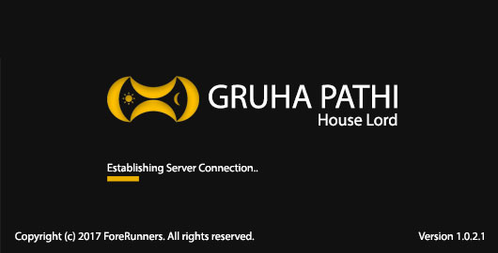If no internet connection is present or if the API is unavailable, the splash screen displays an error message indicating the unavailability of internet otherwise the application loads the login screen

**Login Screen**

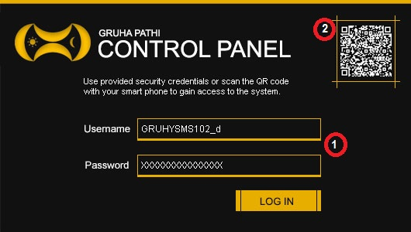

User has two options to gain access to the desktop application.

1. **Gain Access through login credentials**

A user can enter the username and password provided by the system to gain access to the desktop application.

1. **Gain Access by scanning the QR code**

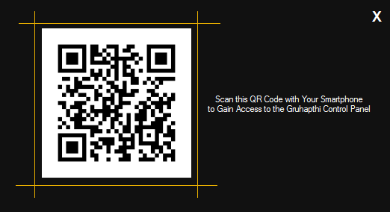A user can scan the QR code generated by the desktop application using the mobile app to grant access to the desktop application.

**Summary Screen**

The screen provides a summary of all the devices and their power consumptions over a period.

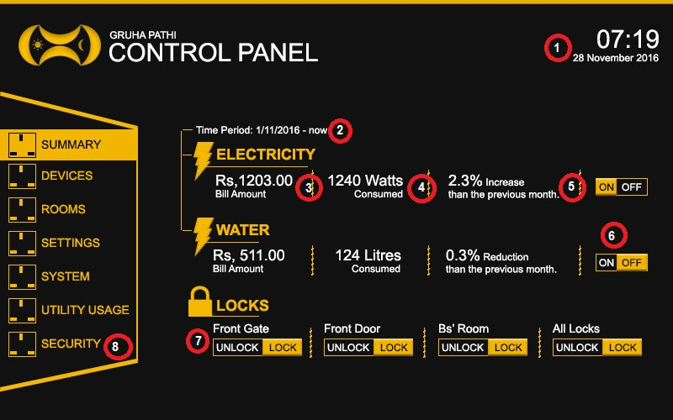

1. **Date & Time**

Displays the current date and time.

1. **Time Period**

Shows the time range from the first of month to the current day.

1. **Bill Amount**

Shows the calculated bill amount of electricity/water consumption.

1. **Unit Consumption**

Amount of units consumed by different power mediums.

1. **Progress**

Displays the amount of power consumption reduced when compared to the last month.

1. **Turn On/Off Power Mediums**

Electricity and water devices can be switched On/Off.

1. **Doors**

Lock and unlock doors and windows.

1. **Navigation Areas**

A user can navigate the application.

**Device Screen**

User can search for smart devices registered with Gruha Pathi System.

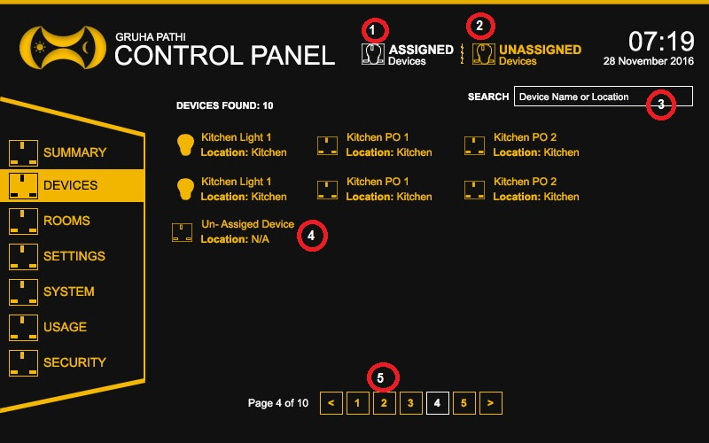

1. **Assigned Devices**

When a user clicks on ‘Assigned Devices’, all assigned devices are displayed to the user.

1. **Unassigned Devices**

When a user clicks on ‘Unassigned Devices’, all un assigned devices are displayed to the user.

1. **Search Area**

A user can search devices by its name or the location it is placed on.

1. **Device Result**

A user can view details of the device by clicking on it

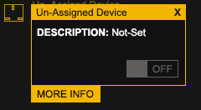

1. **Navigational Area**

User can view device of the selected device result set.

**Floor Screen**

User can create layout plan(s) of floors by placing rooms, windows, doors and other smart devices on the floor layout area.

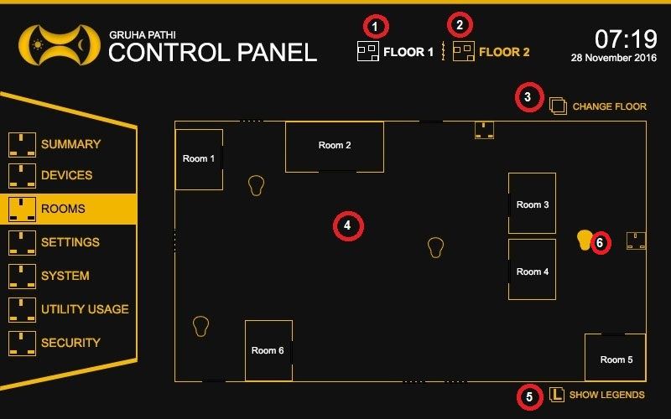

1. **Current Floor**

Shows the selected floor layout.

1. **Floors**

A user can select a floor layout from the drop down.

1. **Change Floor Layout**

A user can add/remove/update smart devices and rooms in the layout floor. A user can also rotate/move and resize rooms and smart device in the floor layout.

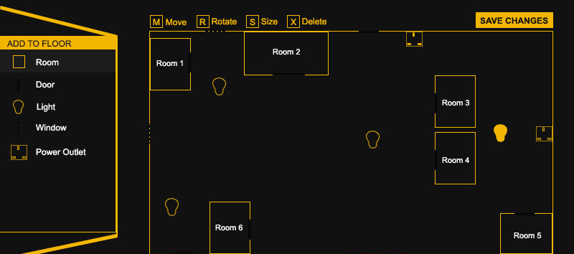

The above screen shows the smart devices that can be added to the layout and what actions that can be performed on them.

1. **Floor Layout Area**

The layout area where smart devices and rooms are placed.

1. **Legends**

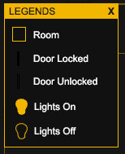Provides and indication about the items in the floor layout

1. **Device Details**

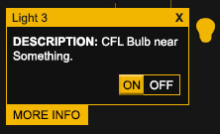Provides information about the device the mouse is placed on. A user can turn On or Off device using this dialog box.

**Settings Screen**

User can change the login credentials and the consumption rates of electricity and water.

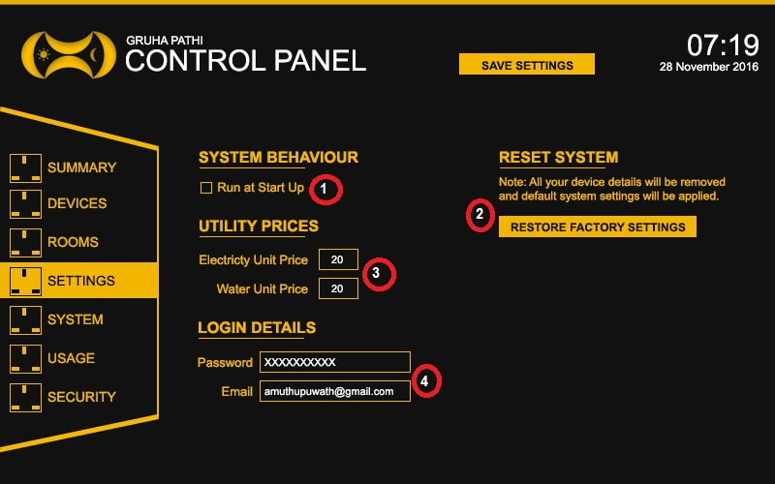

1. **Run at Start Up**

Loads the application when windows start.

1. **Reset System**

User can rest system settings to their default values.

1. **Utility Prices**

User can change the water and electricity unit prices.

1. **Login Details**

Change user password and email address.

**System Screen**

Provides a summary of the status of devices and the software versions.

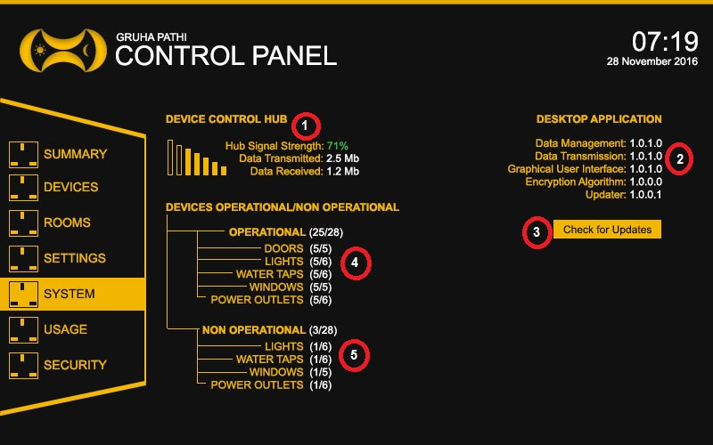

1. **Device Control Hub**

Display the current signal strength, data transmitted and received.

1. **Software Frameworks**

The software versions of the frameworks.

1. **Updates**

Check for latest software and framework updates.

1. **Operational Devices**

Displays all the operational devices of the system.

1. **Non Operational Devices**

Display all non-operational devices of the system.

**Usage Screen**

This screen displays the electricity and water consumption of the smart devices.

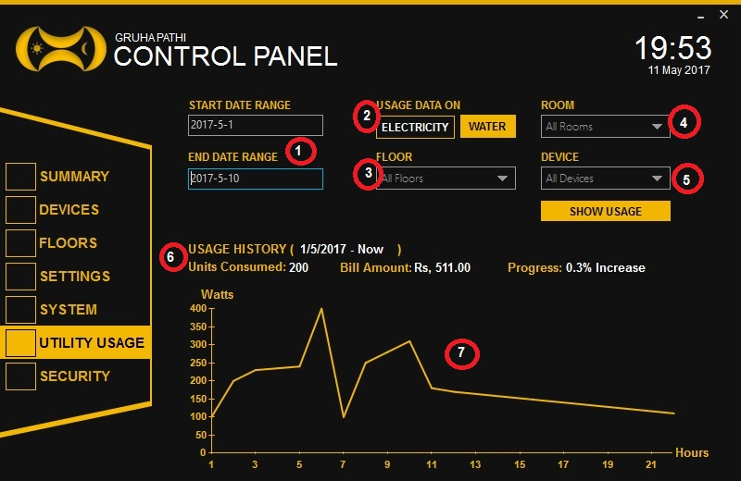

1. **Date Range**

User can select the date range to get smart device consumption details.

1. **Power Medium**

User can select electricity or water to display data.

1. **Location**

Steps 3-5 are used to select the locations.

1. **Location**

Steps 3-5 are used to select the locations.

1. **Location**

Steps 3-5 are used to select the locations.

1. **Usage Data**

Displays all the power consumption details of smart devices.

1. **Graph**

Displays the graph based on consumption data.

**Security Screen**

This screen provides the functionality for the user to lock or unlock smart doors and windows of a premise.

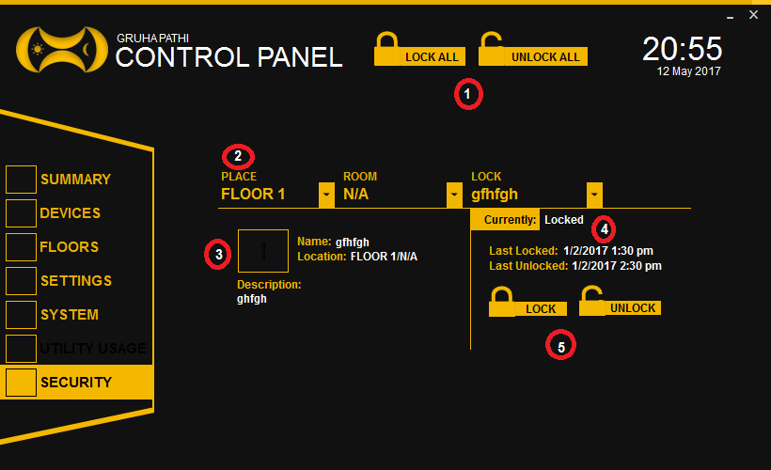

1. **Lock/Unlock All**

Lock or Unlock all smart doors in a premise.

1. **Location**

Location of the smart door.

1. **Device Details**

Details of the device.

1. **Status of the Door**

Displays the last locked date and the status of smart door.

1. **Specific Lock/Unlock**

Lock or Unlock a specific door in a location.

# Appendices II

## Researched Products

### HomeTEC Lanka Solutions

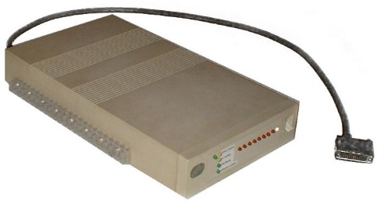 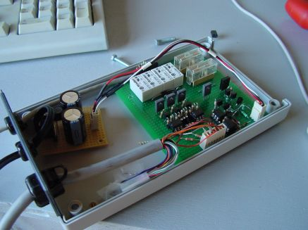 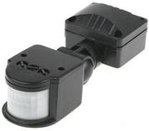

Research Product 1 : Controller Research Product : Controller Research Product 3: Motion Sensor

### Innovative Smart Solutions

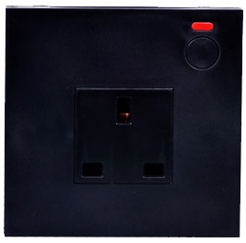

Research Product 4: Smart Plug

### Sri Lanka Telecom

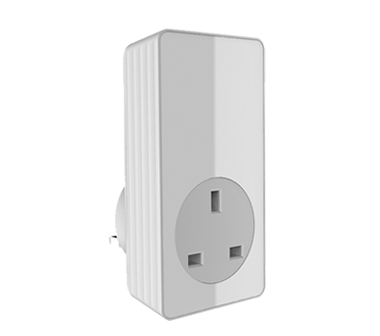 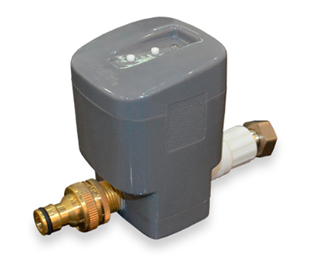

Research Product 5: Wireless Removable Socket Research Product 9: Smart Water Valve

### NOSTERS

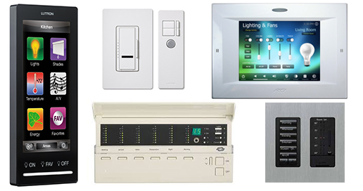

Research Product 6: Lighting Control System

### Dialog Axiata

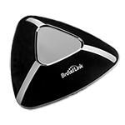 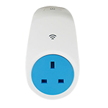

Research Product 7: Smart Remote Research Product 8: Smart Plug

## API Responses



API Response All: All API Requests and Responses

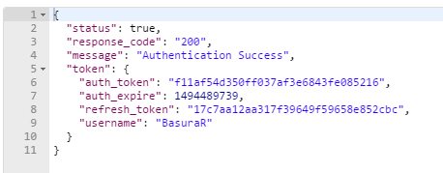 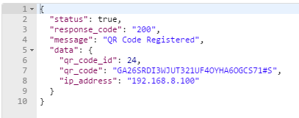

API Response 1: Authentication Successful JSON Response API Response 2: Add QR Code JSON Response

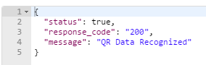 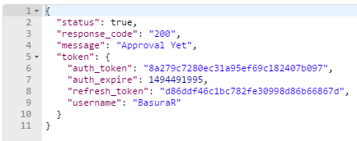

API Response 3: QR Code Recognized in Mobile App API Response 4: QR Code Recognized in PC App

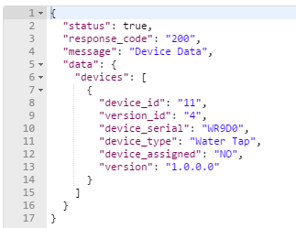 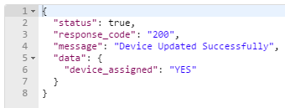

API Response 5: Device Data JSON Response API Response 6: Device Data Update JSON Response

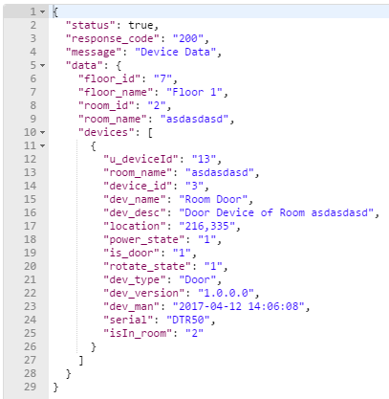 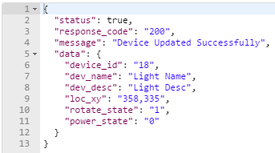

API Response 7: User Device Data JSON Response API Response 8: User Device Data Update JSON Response

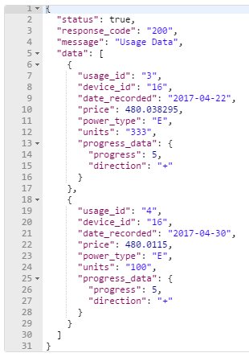 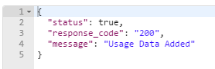

API Response 9: Usage Data JSON Response API Response 10: Add Usage Data JSON Response

## Mobile Application

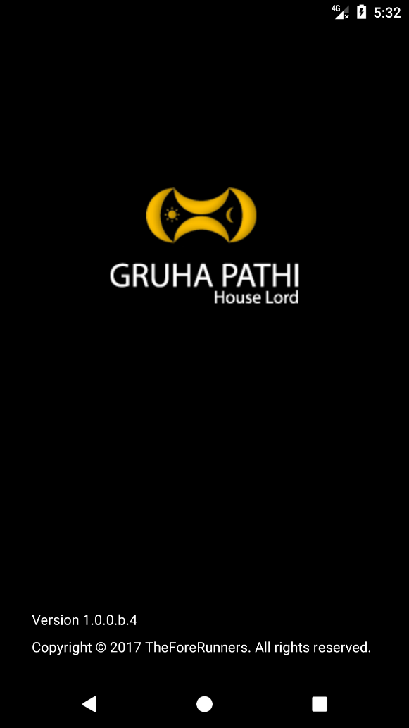 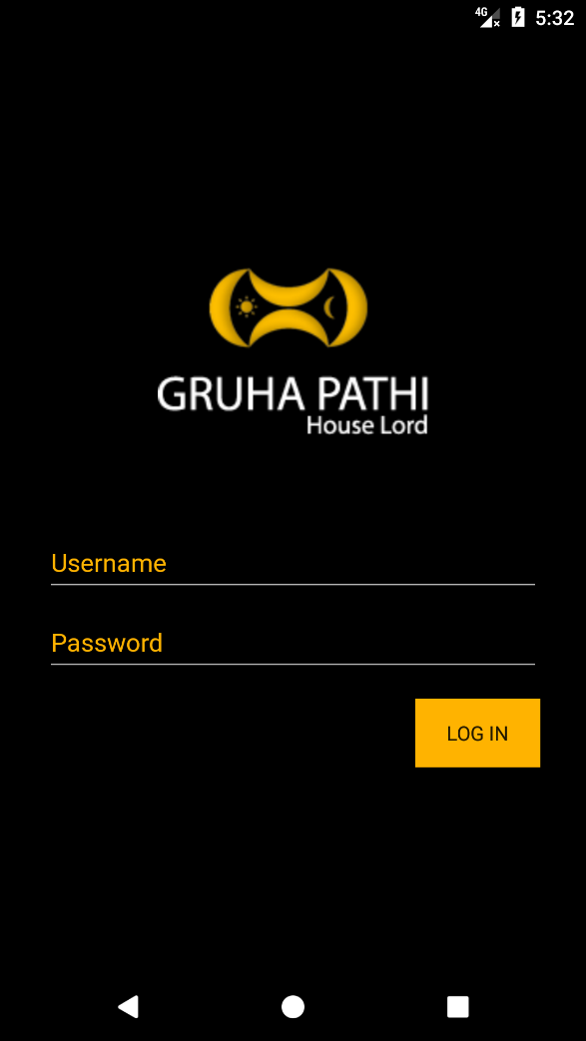

Mobile Application: Summary Screen Mobile Application: Login Screen 1

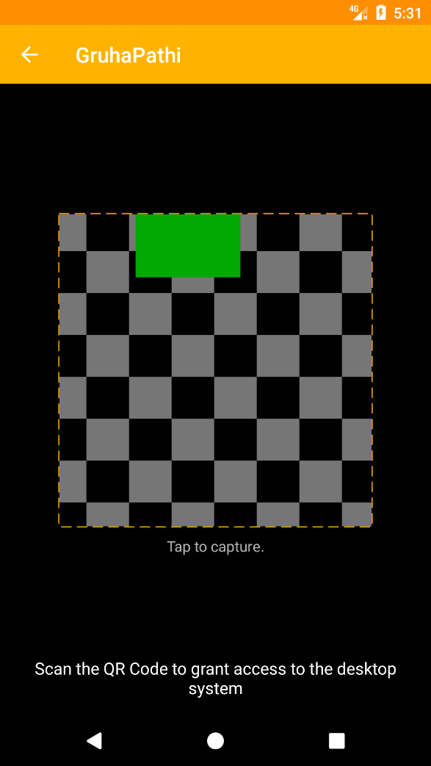 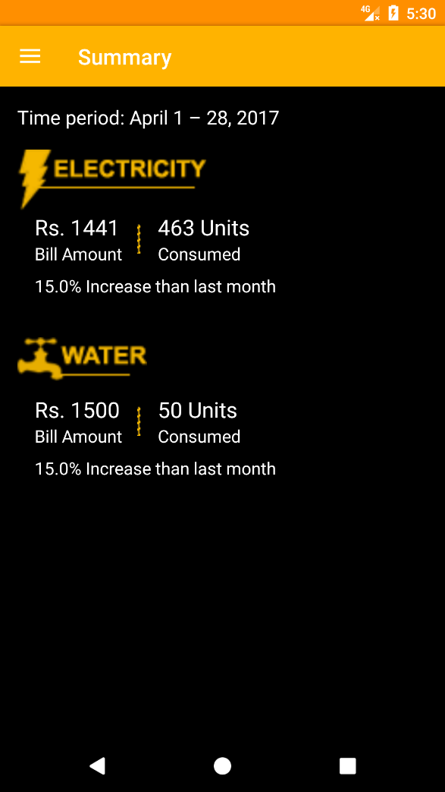

Mobile Application: Login Screen 2 Mobile Application: Summary Screen

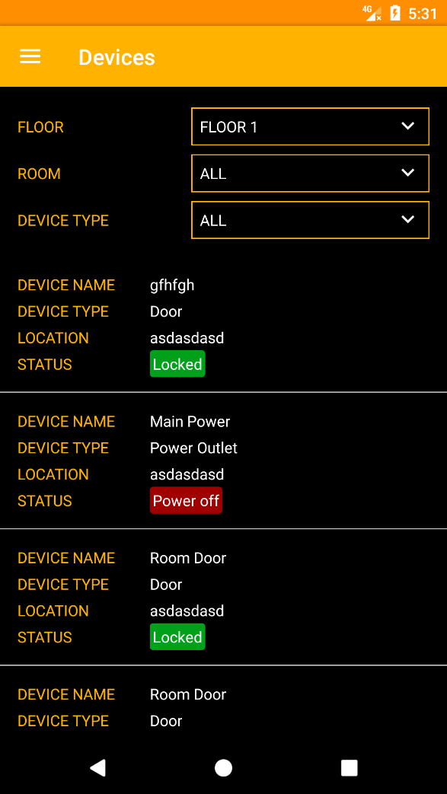 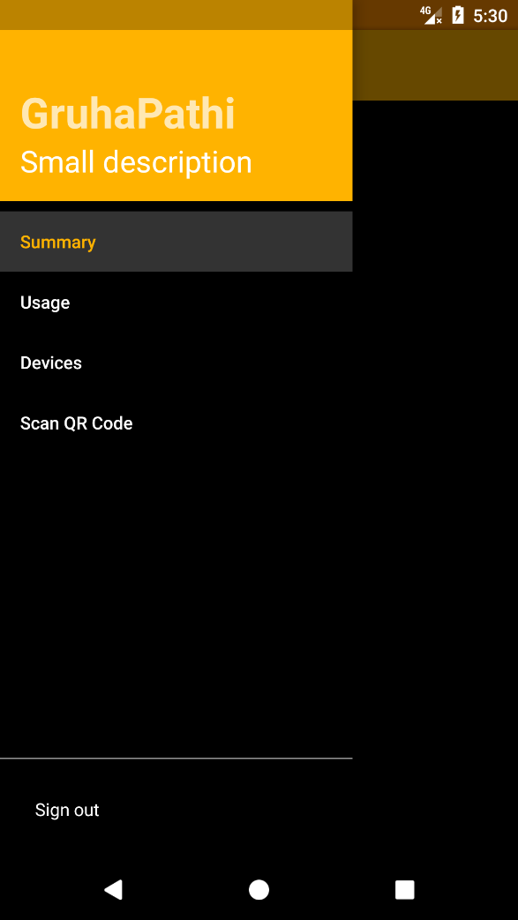

Mobile Application: Device Screen Mobile Application: Side Bar

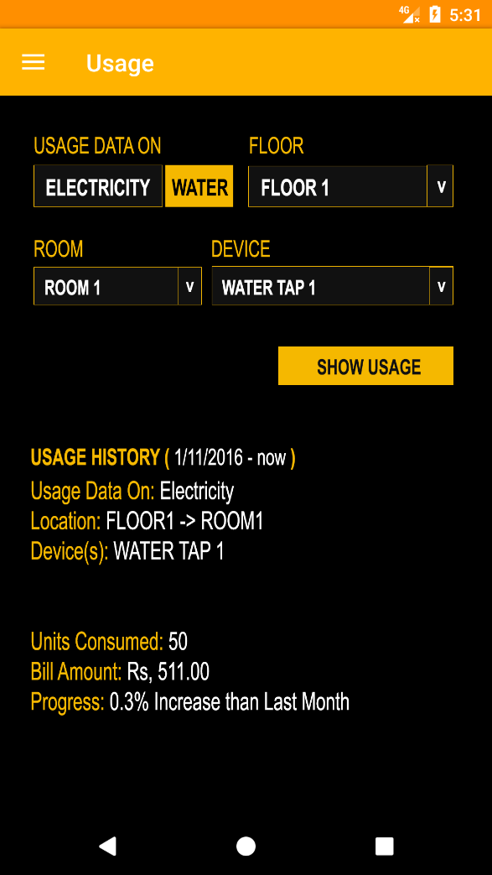 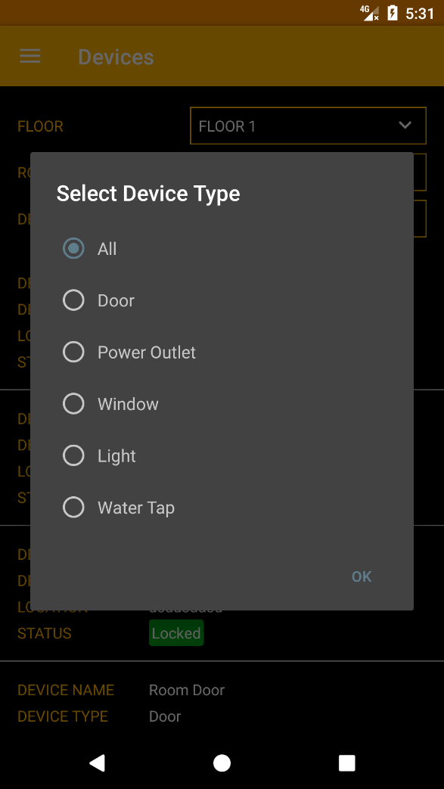

Mobile Application: Usage Screen Mobile Application: Device Types

## Desktop Application



Desktop Application: Splash Screen

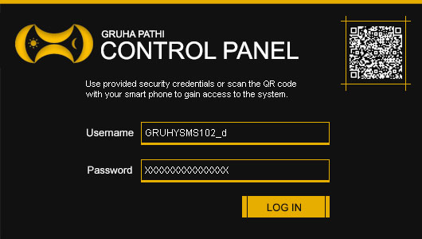

Desktop Application: Sign in Screen



Desktop Application: QR Code

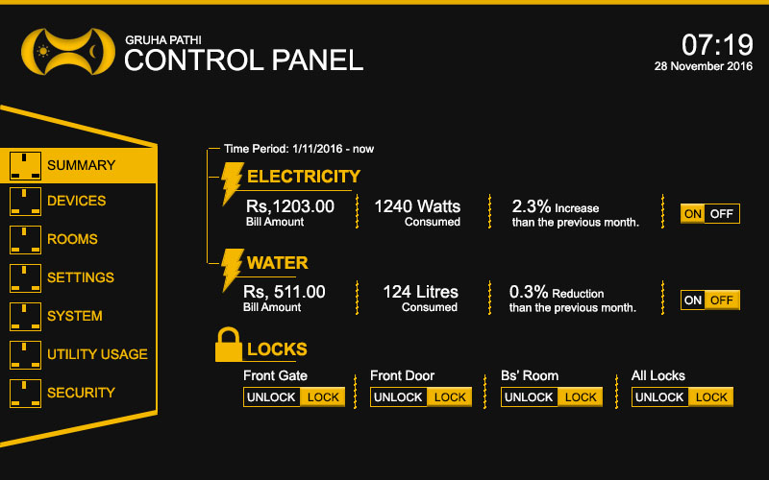

Desktop Application: Summary Screen

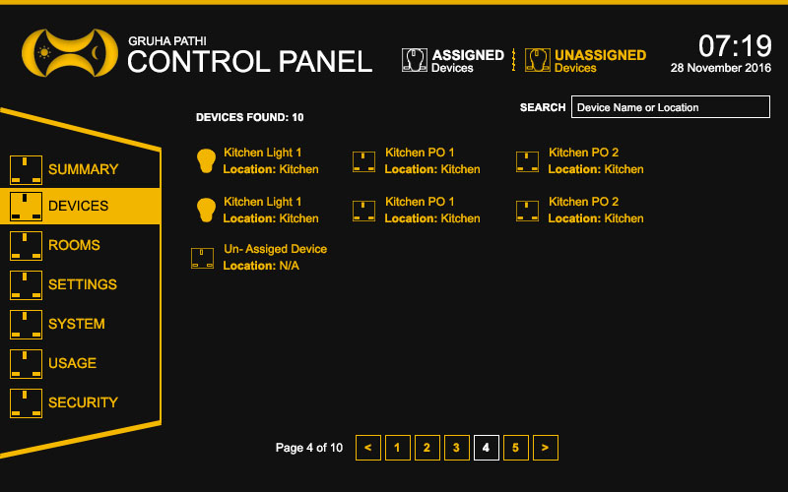

Desktop Application: Devices Screen



Desktop Application: Floor Screen

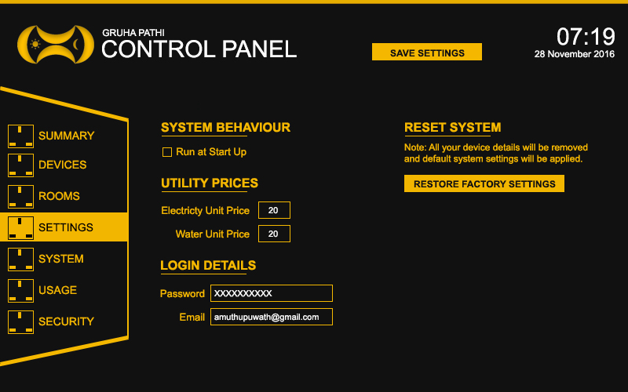

Desktop Application: Settings Screen

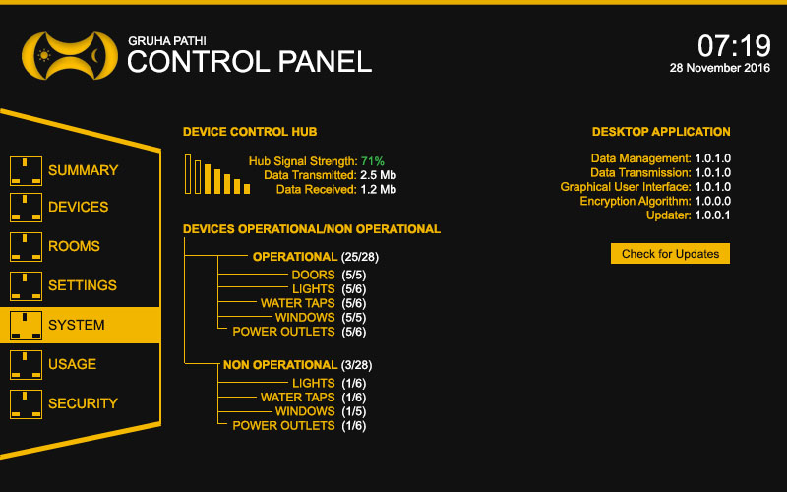

Desktop Application: System Screen



Desktop Application: Usage Screen



Desktop Application: Settings Screen

## Smart Devices

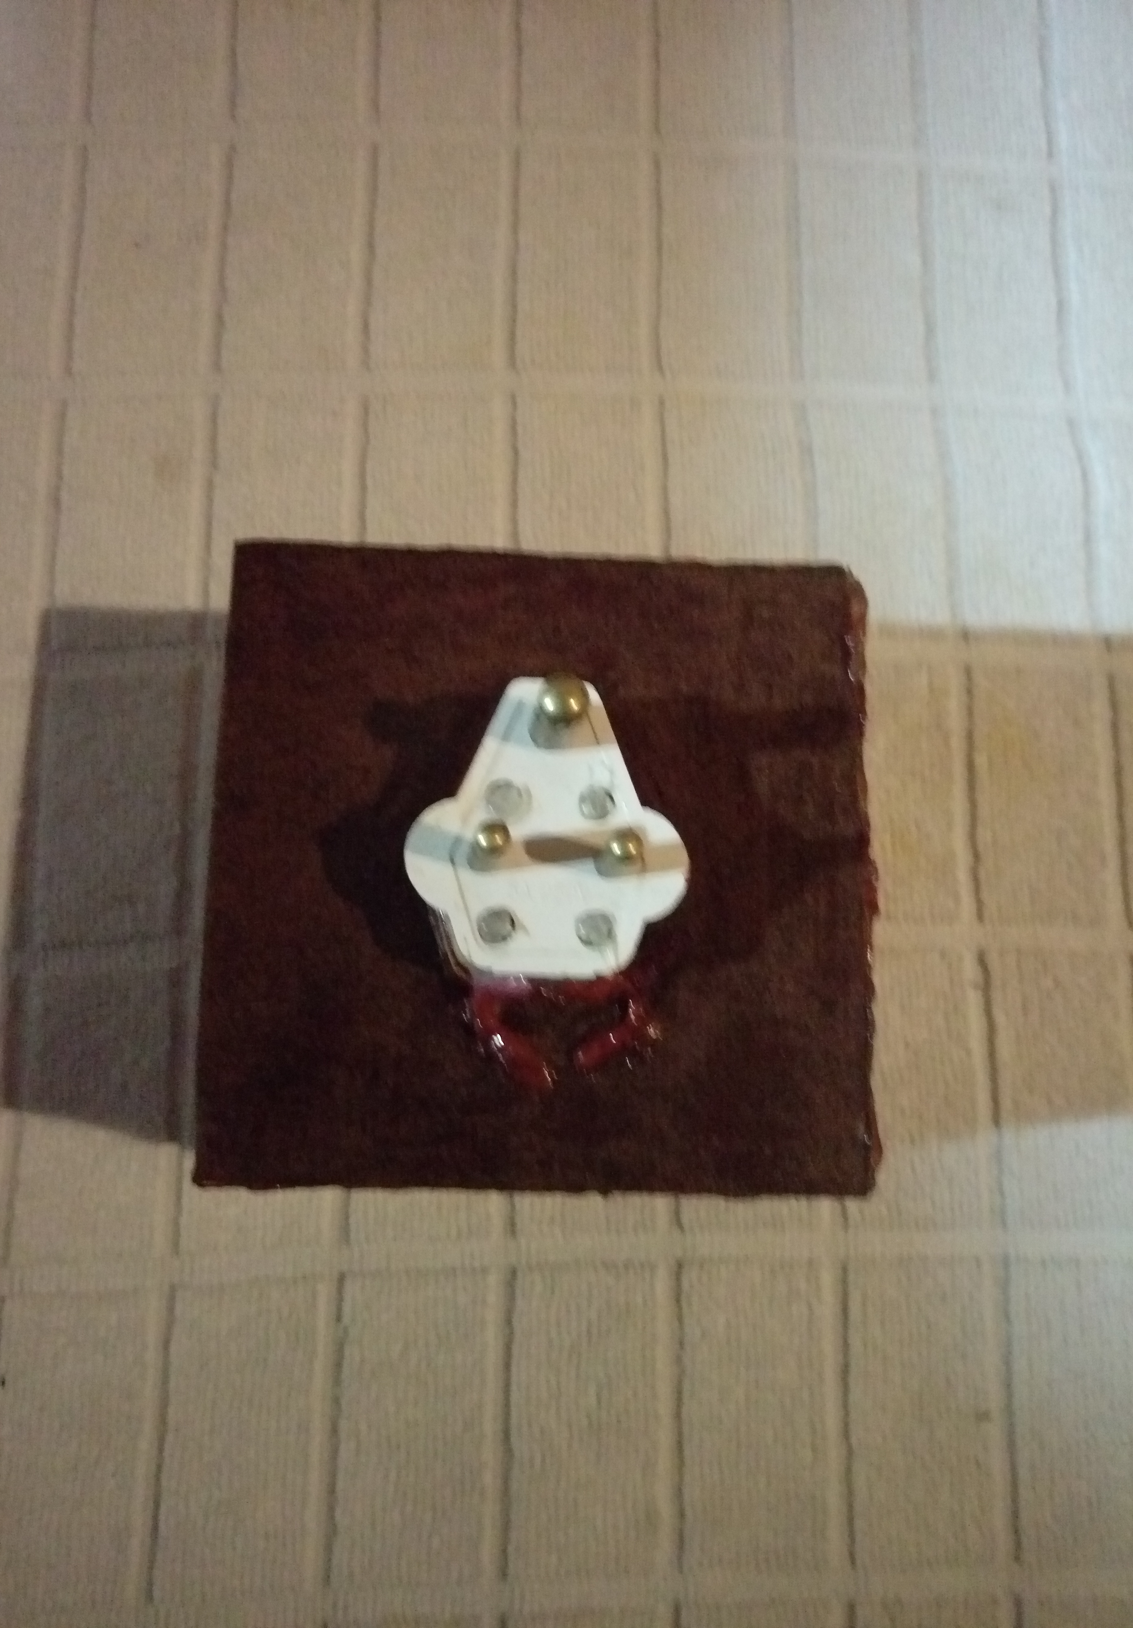 

Smart Device: Socket – Front Smart Device: Socket – Back

 

Smart Device: Light – Front Smart Device: Light - Back

 

Smart Device: Door Smart Device: Water Valve

## Project Initiation Document

**Introduction**

The idea chosen for this project is Home Automation, I named the project as Gruha Pathi (GP) meaning House Lord. Gruha Pathi grants convenience, security and freedom for people to manage their house more efficiently.

All electrical equipment, water supply and house protection acts as a unified system that can automatically take decisions based on the information gathered from numerous sensors placed in the house. Electricity usage and total control over all the electrical appliance plugged into the system can be remotely controlled or let the system take decisions based on the information available.

Water flow management is one of the crucial factors that we fail to address in a house for the simple reason that we have plenty of water available in the country 24/7 but that doesn’t mean pure water is forever available in every part of the country. 80% of water used in the kitchen and in cloth washing machines can be filtered and used in toilets with the help of Gruha Pathi.

*“Don’t let a single drop of rain water flow into the sea.”* – King Parakramabahu the Great.

Simply having a CCTV camera system never helps to protect a house from unwanted parties because after a crime has been committed there is very less reason with having only evidence but an automated system that can protect your house from unwanted parties is an ideal solution, with Gruha Pathi this is possible.

Time is a precious commodity that must not be wasted so instead of manually controlling appliances and knowing the usage it is better to be informed by an automatic system. The main key stakeholders of Gruha Pathi are the house owners.

**Business Case**

**Business Needs**

Present market for home automation in Sri Lanka is almost non-existent. The available products for home automation are separate components that acts individually rather than a complete unified system, for example Dialog Home Automation.

Due to the present busy nature in Sri Lankan workforce most of the household needs and maintenance are never done which paves the way tremendous expenses annually to just maintain and repair. This scenario can be completely remedied through a home automation system that can easily help maintain and organize household needs.

**Business Objectives**

To increase the productivity and effectively manage a house based environment by-

* Establish an awareness of the advantages of Gruha Pathi to increase sales.
* Effectively maintain and observe the electrical, water and gas usages of a house.
* Implement an effective and efficient household protection system that can work as an artificial security officer.
* Build the home automation system at an affordable cost thus the sale of a system can increase the profit.
* The usage reports generated by the individual systems (With the consent of the house owner) can be used as surveys for the improvement of the system.

**Project Objectives**

1. Fully function smartphone application that can manipulate the system to be developed.
2. Complete standalone desktop application that can further enhance the manipulation of the system to be developed.
3. Fully functional hardware components that can work together or alone in a situation and are reliable.
4. To provide security and effective reliance of managing the house tasks with ease.
5. Build a grand database of all survey information generated by individual systems to siphon information that can help develop the system further.

**Initial scope**

Initial Features of the system: -

1. User will be able to control any home appliance from anywhere in the world through the Internet.
2. User will be able to monitor
   1. Current status of the home appliance.
   2. Check water level of the water tank
   3. Home temperature and humidity
3. User will be able to open house door/windows.
4. Integrated Home Security System (burglar Detection)
5. User will be able to do above things using android application or desktop application

**Method of approach**

**Software Development**

Main focus lies in the development of three main controlling components of the system:

1. **Desktop Application**

Enable the user to control the house environment within the house. Contains all the functionality of the smartphone application but lacks the security and authority granting interfaces. Through this application the system can be monitored and manipulated after successful verification from the smartphone application.

**Using Technologies:** C#, MySQL, SQLite and Various frameworks

1. **Smartphone Application**

Enable the user to control the house environment from the outside. Acts as a security and authority granting interface, the controls of the applications can be activated through voice.

**Using Technologies:** Android, Ionic, SQLite, Google Voice API and Various frameworks

1. **Device Driver Applications**

Maintains the control and communication between hardware components and software. These applications are directly embedded on the micro-controllers of each device.

**Using Technologies:** Arduino and C

**Hardware Development**

Main focus lies in the development of the hardware components such as the micro-controllers of each device and a main hardware device that acts as communication relay to all devices connected to the system.

**Using Technologies:** Arduino, Various Electronic Components and Sensors

**Initial Project Plan**

**Control Plan**

**Stage One**

1. Determine the scope of the system to be developed.
2. Analyze the scope and determine necessary information.
3. Investigate products and technologies similar to the system to be developed.
4. Obtain necessary hardware and software components

**Stage Two**

1. Test and gain necessary knowledge of the hardware and software components.
2. Formulate sample schematics and designs for the hardware components.
3. Program the micro-controllers of each hardware component.
4. Formulate sample GUI designs of the software components.

**Stage Three**

1. Build and test the hardware component prototypes.
2. Design and build the GUI designs of the software components.
3. Start coding on the software components.
4. Start integrating hardware and software components.

**Stage Four**

1. Build and test software component prototypes.
2. Debug software and hardware component integration.
3. Re-evaluate the determined scope of the system.
4. Build and test complete prototypes of the system.

**Stage Five**

1. Compile the final report for the system.
2. Test and debug the completed system.

|  |  |  |  |  |  |  |  |  |  |  |  |  |
| --- | --- | --- | --- | --- | --- | --- | --- | --- | --- | --- | --- | --- |
| Stage | October | November | | December | | January | | February | | March | | April |
| **One** |  |  |  | |  | |  | |  | |  | |
| **Two** |  |  |  | |  | |  | |  | |  | |
| **Three** |  |  |  | |  | |  | |  | |  | |
| **Four** |  |  |  | |  | |  | |  | |  | |
| **Five** |  |  |  | |  | |  | |  | |  | |

**Communication Plan**

Arrange supervisor meetings as necessary, planned review/feedback meetings will be held at the end of each stage in order to discuss the End-Stage report, the next Stage plan, and to review any technical deliverables produced during the stage. Feedback meetings will also be held following the submission of the two Interim reports.

**Initial Risk List**

|  |  |
| --- | --- |
| Risk | Management Strategy |
| **Software** | Employ version controlling into the system. |
| **Hardware** | Have backup hardware components. |
| **Time Constraints** | Complete the system with less non-functional needs. |
| **Learning Technologies** | Simple prototypes will be built in stage two to understand and learns the technology. |

**Initial Quality Plan**

|  |  |
| --- | --- |
| Check | Management Strategy |
| **Design Validation** | Check software and hardware interface design after completion of each prototype. |
| **Requirements** | Requirements will be checked after each stage and a thorough check will be done in stage 4 to ensure that they are correct, relevant complete, achievable and demonstrable. Prototyping and user interviews will be employed. |
| **Component Integration Quality** | To be conducted at the end of each prototype |
| **System validation and user acceptance** | To be conducted at the start of Stage 4 |

## Stage Plans

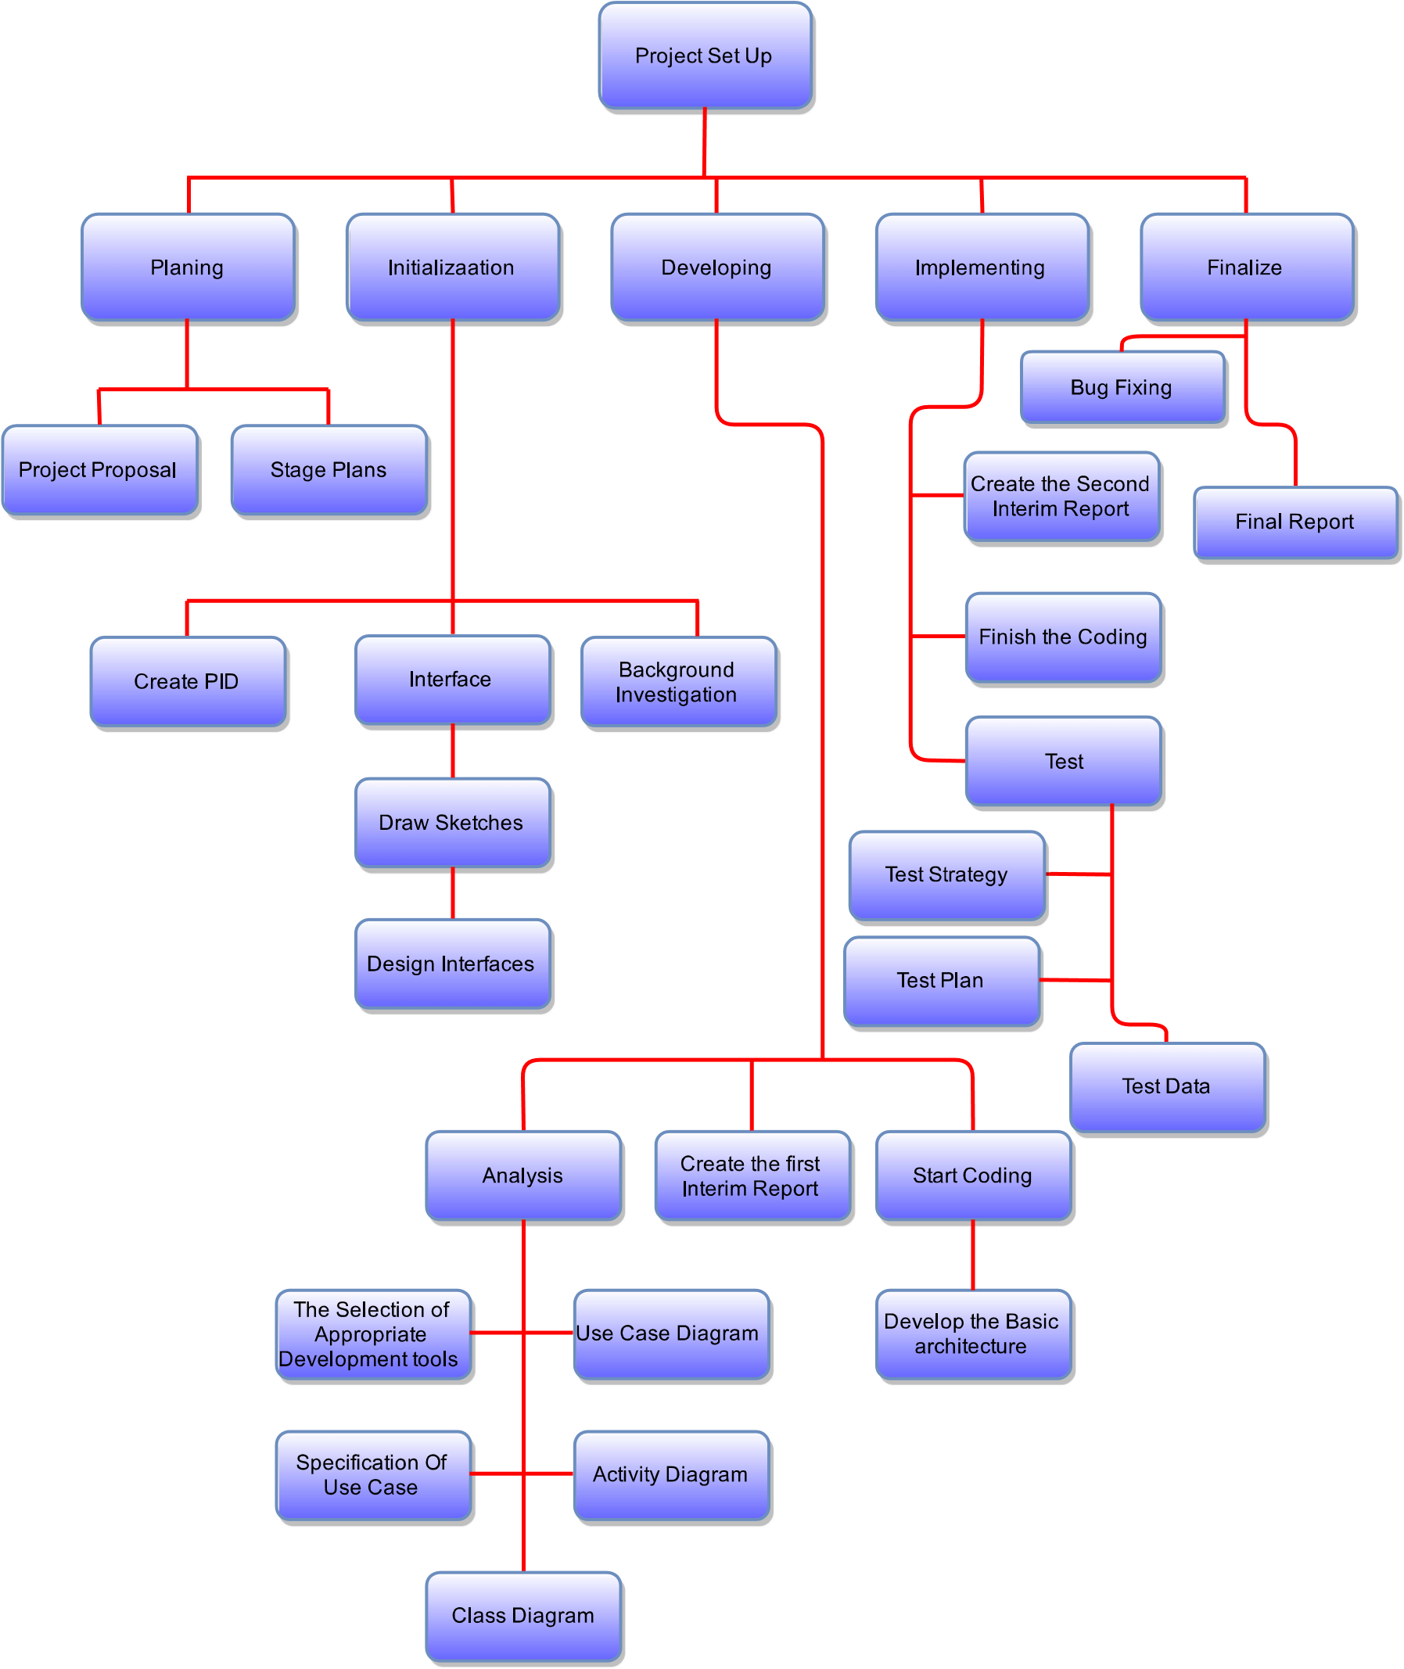

## First Interim Report

**Tasks Undertaken and Outcomes**

1. **Acquisition of Electronic Components**

As planned, on October began to purchase the electronic components such as capacitors, resistors, transistors, ICs and Sensors that are required for the completion of the project. Managed to purchase all required electronics for the project by November ahead of schedule.

1. **Development of Hardware Components**

As planned began work on the core hardware components on November and managed to build and test prototypes of the core hardware components ahead of schedule.

* **Transformer Circuit,** is used to transform mains voltage (230V AC) to variable outputs 5V and 12V DC.
* **Communication Circuit**, is used to transmit and receive data and commands between devices. 433 MHz frequency based transmitter and receiver is used to accomplish this task.
* **Relay Circuit,** controls the switch ON/OFF state of 230V device.
* **Voltage Measurement Circuit,** measure the amount of WATT/h used by the external device.
* **Motion Circuit,** uses a PIR sensor which detects movement and activates the relay circuit.
* **Processor Circuit,** controls and manages all the sub components (Communication, Relay and Motion circuits) of the device. This is accomplished by an ATMEGA328-PU IC;
* **Switch Device,** comprises of the above mentioned four circuits. The purpose of this component is to provide the user with the ability to wireless switch ON/OFF a device and obtain the power consumption of the device to which it is connected.
* **Power Socket Device,** is designed similar to the switch component the only difference being the device attached to the power socket can be changed at will.

1. **Development of GUI Designs**

As planned began work on the GUI designs on November and managed to design only two GUIs as of now. Running behind schedule on development of GUI Design.

* **Splash Screen,** when the application is executed before it fully loads, checks for all software components, internet connection, and device validation.
* **Login Screen,** asks the user to input login credentials in order to gain access to the system.

**Products Produced and Product Quality**

1. **Switch Device and Power Socket Device.**

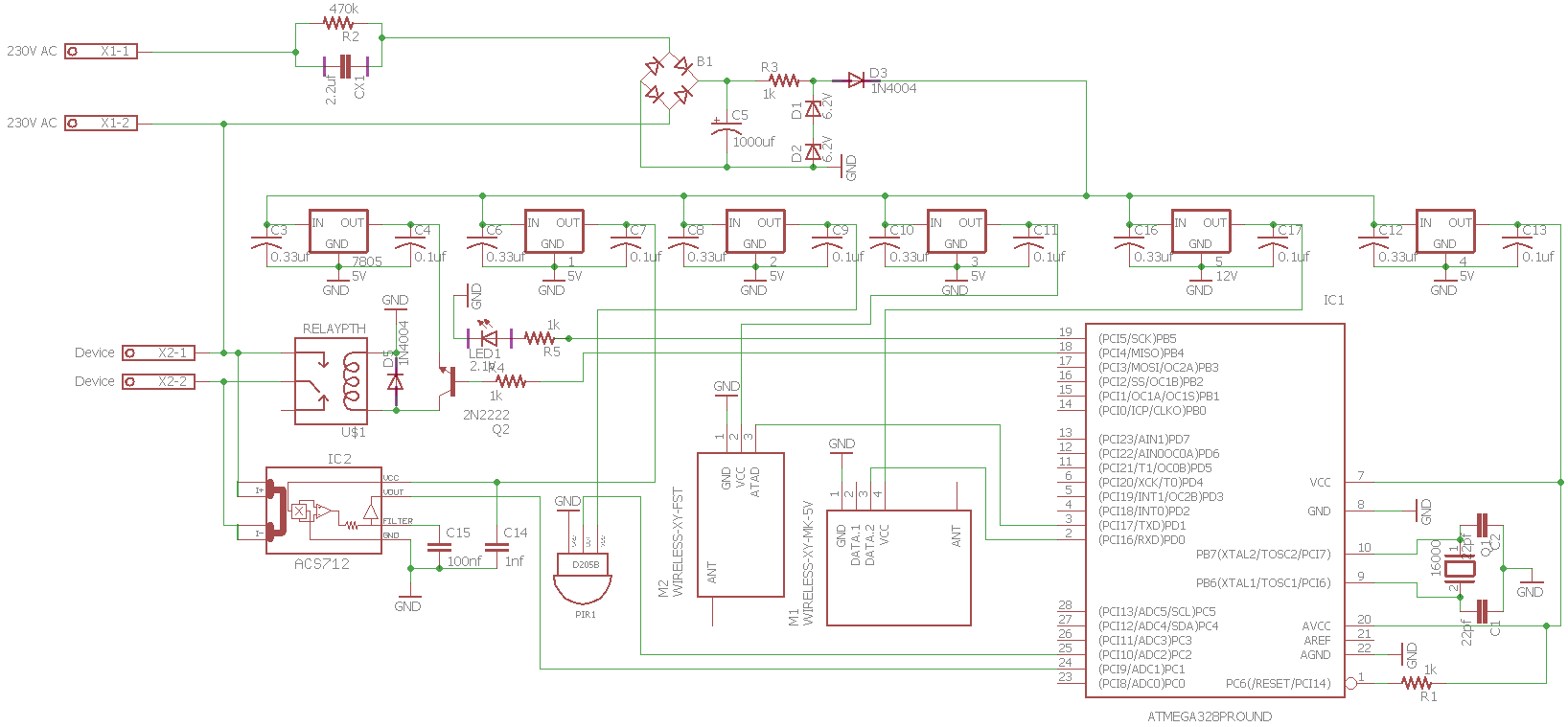Managed to reduce the size of the device by removing transformer and introducing a diode based rectification. This device can fit into a normal switch or power socket at any home.

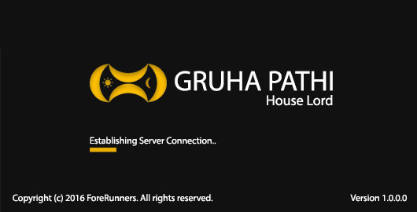

1. **Splash Screen**

Scan the system on application start up, check for the availability of the internet connection and validate the device before launching the Log in interface.

1. 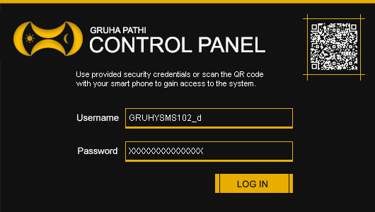**Login Screen**

A user can log into the system using username and password combo or else by the using their smartphone to scan to QR Code to gain access.

**Risks that have Materialized and Solutions**

1. **Voltage Transformation**

Transforming 230V AC (Mains) to 5V and12V DC (Variable Outputs) with 1 amp posed a great challenge. To transform Mains to Variable output required an electrical transformer which was large in size, I fixed this issue by using capacitor based transformation and use voltage regulator ICs to obtain 12V, 5V DC respectively.

1. **Wireless** **Communication**

RF 433MHZ wireless communication (RF Modules) is used to receive and transmit data and commands to and from devices. The issue faced here was the initial range of RF module transmission distance which was 12cm, after much research managed to solve it by using a signal booster and a 17cm long antenna.

1. **Size of Components**

With the circuit prototype testing it became evident that size of the devices has increased by 20% in comparison to the initial planned component size. The solution for this issue would be to use SME (Surface Mounted Electronic) but I have no experience with them as of now, I plan to gain knowledge on the subject.

1. **Size of Memory**

The storage capacity of ATMEGA328-PU is 32KB which is not enough to store all the planned functionality of the device therefore in order to solve the issue I used ROM IC 24c64 which contains a capacity of 32 KB the resulting storage capacity is 64KB (ATMEGA328-PU + 24c64).

**Schedule**

**On Schedule Little Off Schedule Failed to Complete Not Started**

|  |  |  |  |  |  |  |  |  |  |  |  |  |
| --- | --- | --- | --- | --- | --- | --- | --- | --- | --- | --- | --- | --- |
| Stage | October | November | | December | | January | | February | | March | | April |
| **One** |  |  |  | |  | |  | |  | |  | |
| **Two** |  |  |  | |  | |  | |  | |  | |
| **Three** |  |  |  | |  | |  | |  | |  | |
| **Four** |  |  |  | |  | |  | |  | |  | |
| **Five** |  |  |  | |  | |  | |  | |  | |

**Resources**

Project capital is Rs. 10,000. As of now 40% of the capital was spent purchasing electrical and electronic components. The following items were purchased,

**Hardware**

* Electrolytic and Ceramic Capacitors (1nf – 1000uf)
* Resistors (100ohms – 1mega ohm)
* Transistors (PN2222A, TIP120, BD140)
* Integrated Circuits (ATMEGA328-PU, LM7805, LM7812, ACS712, 24C64, NE555)
* Sensors (PIR, IR)
* Others (Servo, Motor Shield, Water Flow Detector, Arduino Uno, LAN Shield, WIFI Shield, 433mhz Transmitter, 433mhz Receiver, etc.)

**Software**

* CADSOFT Eagle

**Learning Undertaken**

* **Research on Home Automation Systems**

Presently in Sri Lanka, there are no home automation systems only collections home automation gadgets and lacks a complete functional system. There are only two major home automation gadget providers in Sri Lanka

1. **Dialog Smart Home,** lacks a complete functional system and use independent gadgets from Movinta.
2. **HomeTec Lanka,** has no functional system but independent gadgets that work over Wi-Fi.

* **Micro-Controller Programming**

Learned Arduino based programming and to operate sensors connected to Arduino

* **Electrical and Electronic Theories**

Learned the basics of electronics in order to create schematics and circuits from schematics.

* **Smartphone Application Development**

Gained the basic knowledge to create a smartphone application using Android Studio, Phone Gap and Ionic Framework.

**References**

1. Dialog and Movinta Pioneer Smart Home Technology. Dialog. Available at: <https://www.dialog.lk/smarthome>
2. Your Trusted Partner in Security & Home Automation Since 2008. HomeTec Lanka. Available at: <http://www.hometeclanka.com/index.html>
3. YouTube Channel. Electronics. Available at: <https://www.youtube.com/user/makemagazine/playlists>
4. YouTube Channel. Android Development. Available at: <https://www.youtube.com/playlist?list=PLAgylfU8wrtvWlSlVhFQZtE311sProxQF>
5. YouTube Channel. Android Development. Available at: https://www.youtube.com/playlist?list=PLAgylfU8wrtvWlSlVhFQZtE311sProxQF

## Second Interim Report

**Tasks Undertaken and Outcomes**

1. Development of Control Hub

The Control Hub controls the devices in the house using RF 433 MHz frequency and manages data transmission between web server and the devices. Acquired the required electronic components and the construction is almost 5% completed.

1. Development of Door and Window Controller

This device open and close a window/door according to inputs from the Control Hub. The construction is almost 40% completed.

1. Development of Water Tap Device

This device controls the flow of water and also retain its usage and transmit to the Control Hub. Construction is about 50% completed.

1. Development of Mobile Application

The construction is almost 20% completed.

1. Development of Database

The database is built using MySQL and will be hosted on the web server. The construction is almost 90% completed.

1. Development of Web Server API

Started work on the API to support the Control Hub, Mobile and Desktop application data transmissions and will be hosted on a shared hosting site. The construction is 10% completed.

**Products Produced and Product Quality**

**Hardware Components**

**Light Device and Power Outlet Device.**



Made Printed Circuit Boards(PCB) for the devices by printing them onto copper boards and using Ferric Chloride to remove excess copper. Then soldered the electronic components onto the PCBs *(Refer Figure 2 & 3)*.

I used Cad Soft Eagle to design the PCB design and a 60W soldering iron for PCB soldering. The circuit was kept powered up for 24hrs to test its performance and durability.

Figure 1: Printed PCB on Paper

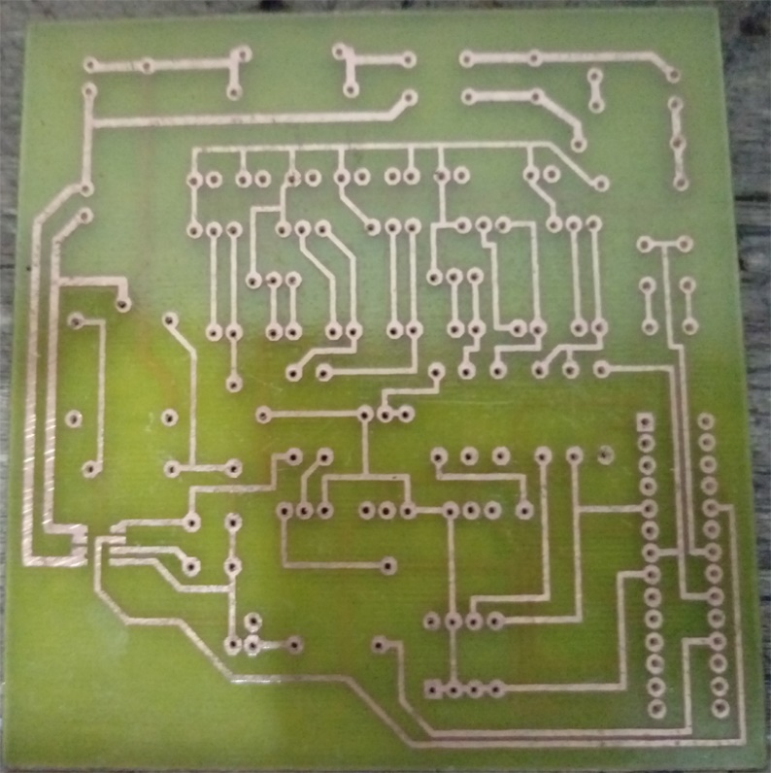

Figure 2: Printed PCB

Figure 3: Printed PCB with Components Soldered

The PCB uses a 433mhz transmitter and a receiver for communication and a PIR sensor to detect movement to decide whether to switch ON/OFF device.

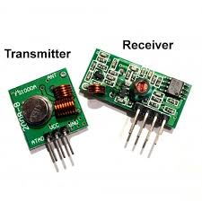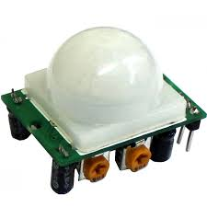

Figure 5: 433Mhz Transmitter and Receiver

Figure 4: PIR Sensor

**Software Components**

**Desktop Application**

Managed to create all GUIs of the desktop application suitable for integration with the web server. This application can control all aspects of the house connected with the system.

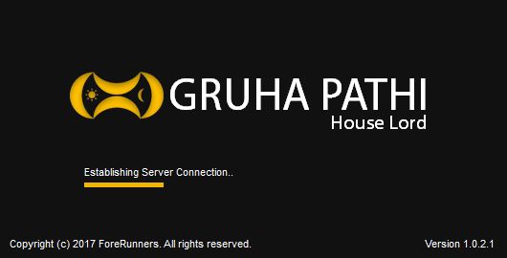 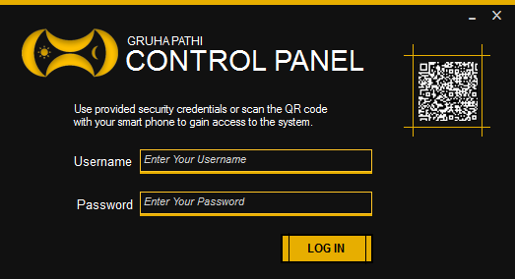 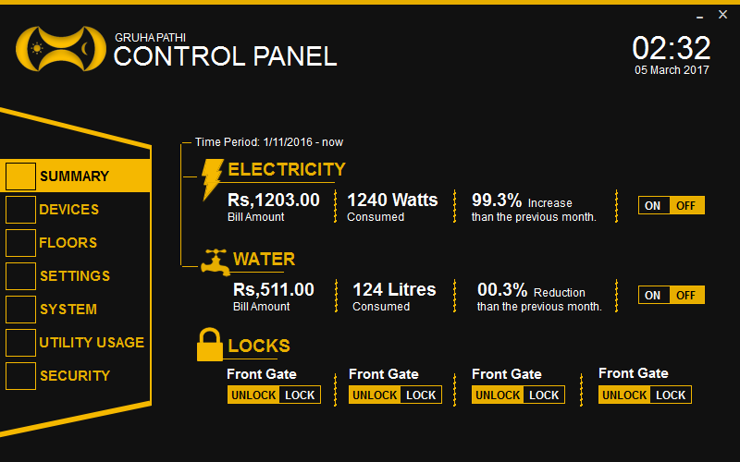 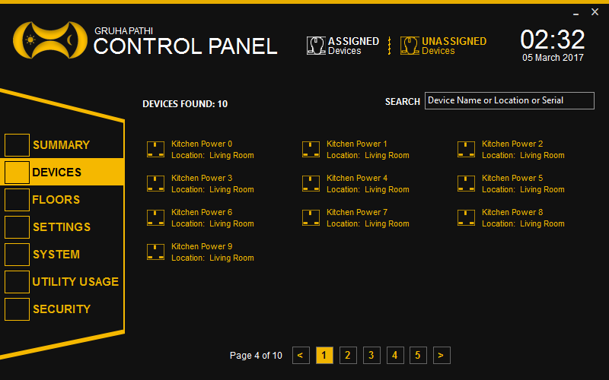 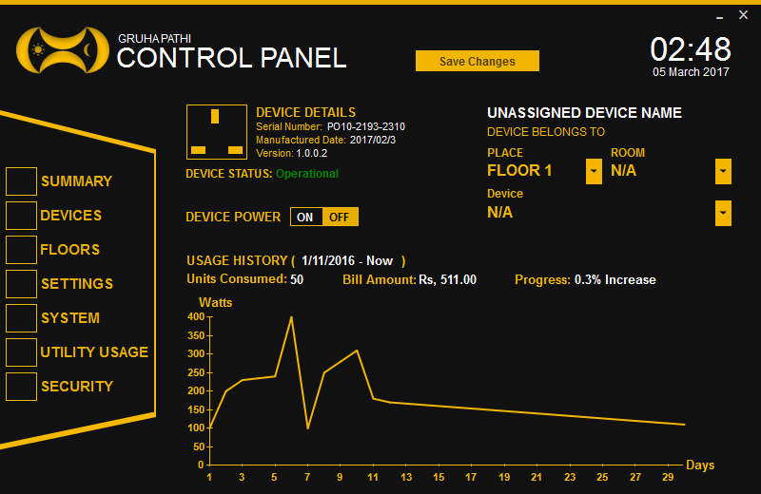 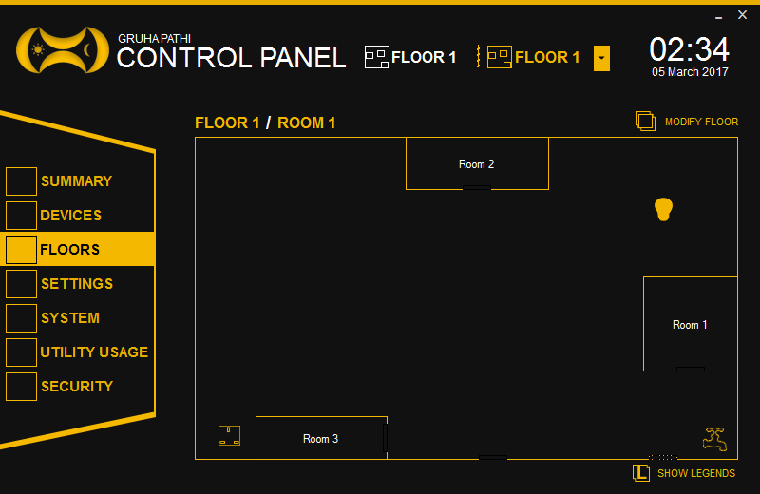

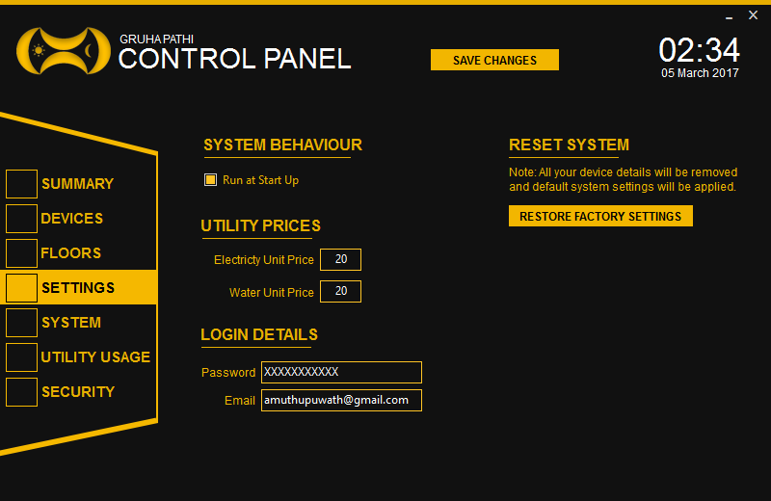 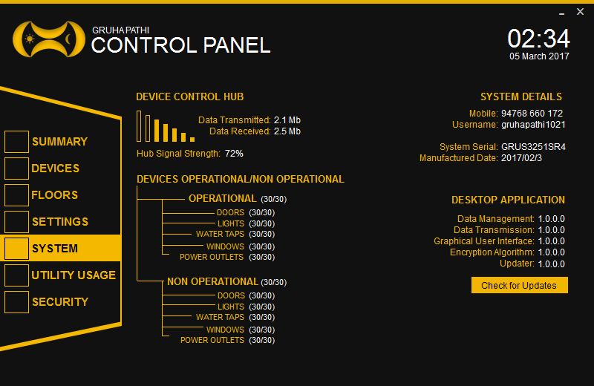

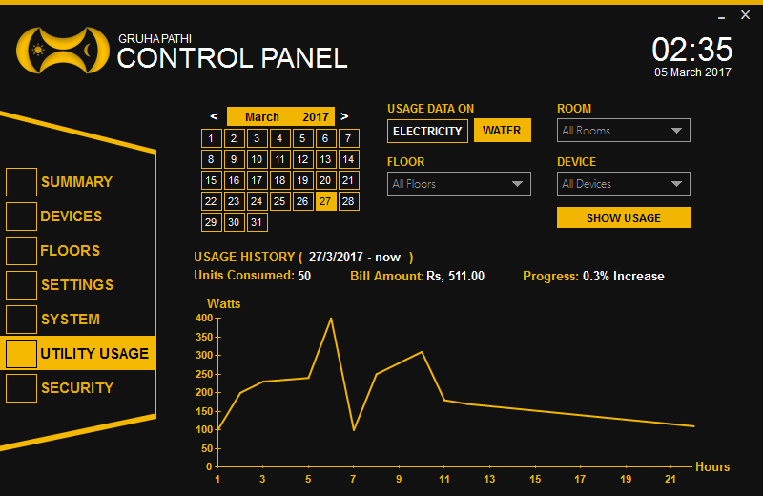 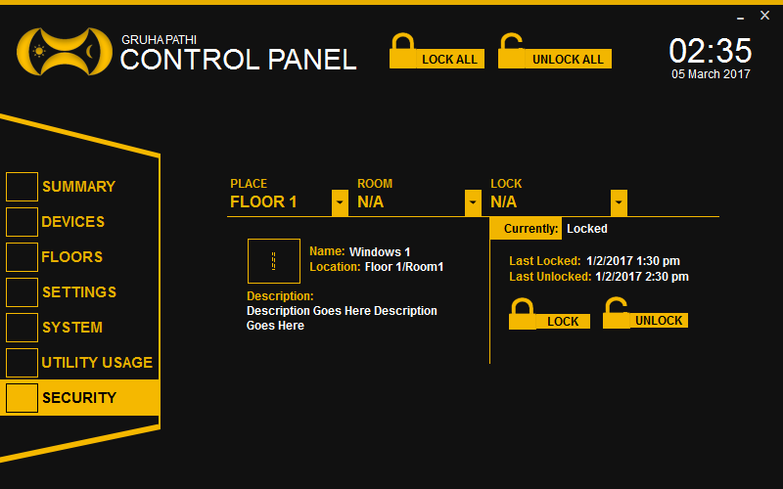

**Mobile Application**

Managed to create all GUIs of the mobile application suitable for integration with the web server. The mobile application has partial functionality when compared with the desktop, this is used mainly to receive notifications and grant user the access to the desktop system. The application is currently designed for android smartphones but can be extended for other platforms if desired.

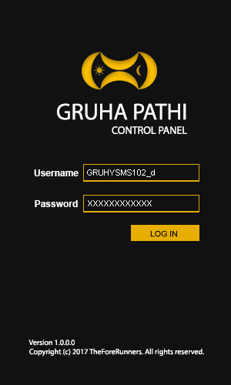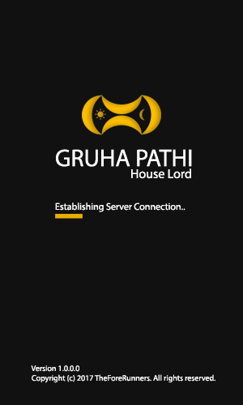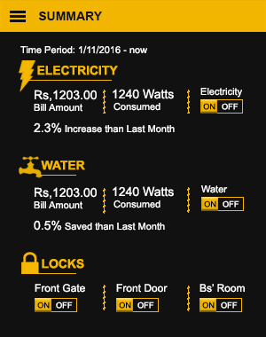

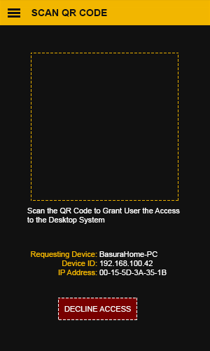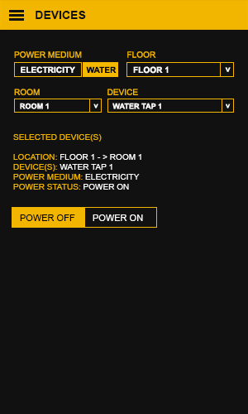

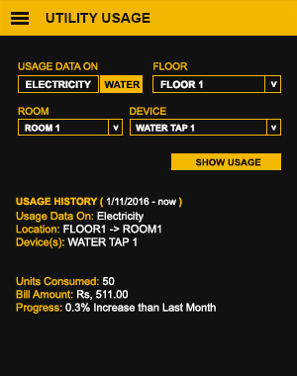

**System Diagram**

The system receives commands from the web server to the Gruha Pathi Control Hub through the Home Router, this uses LAN based internet. All the other devices use 433 MHz frequency for commands and data transferences, this in turn doesn’t waste the home internet unnecessarily.



**Risks that have Materialized and Solutions**

1. **Limited Time**

I am currently enrolled in an internship at a company so it’s a but complicated to stick to the schedule that I have formulated for the successful completion of the project and I will try to stick to the schedule as much as possible.

1. **Lack of Electrical and Electronic Advanced Concepts**

I have to practically demonstrate the electrical and electronic concepts which are new to me in order to build my circuits. I have done tremendous amount of research and self-learning on YouTube/Linda in order to learn the concepts of building circuits. I could have bought prebuilt circuits but I decided to build them on my own because most of the prebuilt circuits are not suited for my tasks.

1. **Lack of Resources**

I planned the project budget to be around Rs. 10,000 but with the increasing amount of prices of components it had to be increased to Rs. 20, 000. The money spent on this project are solely from my internship salary and I haven’t borrowed a single dime from a third party including my parents because I wanted to do this completely on my own.

1. **Building the Mobile Application**

Native android application development is a bit complicated but I will try to overcome that and build a good look, working mobile application.

**Schedule**

On Schedule Little Off Schedule Failed to Complete Not Started

|  |  |  |  |  |  |  |  |  |  |  |  |  |
| --- | --- | --- | --- | --- | --- | --- | --- | --- | --- | --- | --- | --- |
| Stage | October | November | | December | | January | | February | | March | | April |
| One |  |  |  | |  | |  | |  | |  | |
| Two |  |  |  | |  | |  | |  | |  | |
| Three |  |  |  | |  | |  | |  | |  | |
| Four |  |  |  | |  | |  | |  | |  | |
| Five |  |  |  | |  | |  | |  | |  | |

**Resources**

Project capital of Rs. 10,000 had to be increased to 20, 000. As of now 60% of the capital was spent purchasing electrical, electronic components and etc. The following items were purchased,

Hardware

* Electrolytic and Ceramic Capacitors (1nf – 1000uf)
* Resistors (100ohms – 1mega ohm)
* Transistors (PN2222A, TIP120, BD140)
* Integrated Circuits (ATMEGA328-PU, LM7805, LM7812, ACS712, 24C64, NE555)
* Sensors (PIR, IR)
* Others (Servo, Motor Shield, Water Flow Detector, Arduino Uno, LAN Shield, WIFI Shield, 433mhz Transmitter, 433mhz Receiver, etc.)
* Double Sided Copper Plates
* Ferric Chloride
* Soldering Iron and Solder
* PCB Drill

Software

* CADSOFT Eagle
* Web Server (Need to Purchase)

**Learning Undertaken**

* Micro-Controller Programming

Learned Arduino based programming and to operate sensors connected to Arduino

* Electrical and Electronic Theories

Learned the basics of electronics in order to create schematics and circuits from schematics.

* Smartphone Application Development

Gained the basic knowledge to create a smartphone application using Android Studio, Phone Gap and Ionic Framework.

* PCB Building

Watched video tutorials on how to build commercial PCBs using fabrication with great difficult managed to build a good looking PCB.

**A Draft TOC of Final Project Report**

1. Abstract
2. Acknowledgement
3. Declaration
4. Introduction
5. Background and Research
   1. Domain Research
      1. Problem Identification
      2. Extent in Determining the Scope
   2. Technical Research
      1. Analysis of Research Technologies
      2. Evaluating the Problem Scope
6. Business Case
7. Project Objectives
   1. Functional Requirements
   2. Non-Functional Requirements
   3. Usability Requirements
   4. Development Requirements
8. Scope of the Project
9. Design
   1. Use Case Diagram
   2. Activity Diagram
   3. Class Diagram
10. UI and UX design
11. Use of Human Computer Interaction (HCI)
12. User Documentation
    1. Functionality/ User Manual
    2. Supporting platforms
13. Known Bugs
14. Desired improvements
15. Conclusion
16. Bibliography
17. Appendices
    1. Supervisor meetings
    2. Project initiation document
    3. Interim reports

## Records of supervisory meetings

